**Government of karnataka**

**Department of Ayush**

**Government ayurveda research center, Mysuru**

**In association with SDM ayurveda medical college, Hasan**

**A SIGNLE ARM MULTICENTRE STUDY TO ANALYZE THE EFFECT OF SINGLE DOSE ( ANUBHOOTA YOGA) OF PIPPALI(*PIPER LONGA*) AND MARICA( *PIPER NIGRUM* )IN BANANA ON MRIGHASHIRA POORNIMA IN PRANAVAHA SROTO DUSTI VIKARAS VIS – A- VIZ RESPIRATORY DISORDERS**

**BY**

**DR. PRIYANKA**

**GUIDED BY**

**DR L N SHENOY**

**MAJOR RESEARCH PROJECT SUBMITTED TO**

**____________________________________**



**DEPARTMENT OF SAMHITHA SIDDANTHA**

**SHRI DHARAMSTHALA MANJUNATHESHWARA COLLEGE OF AYURVEDA & HOSPITAL, HASSAN – 573201**

**IN ASSOCIATION WITH**

**GOVERNEMENT AYURVEDA RESEARCH CENTER**

**MYSURU**

**Government ayurveda research center, Mysuru**

**In association with**

**SDM ayurveda medical college, hasan**



**DECLARATION BY THE RESEARCHER**

I hereby declare that this project entitled “**A SIGNLE ARM MULTICENTRE STUDY TO ANALYZE THE EFFECT OF SINGLE DOSE ( ANUBHOOTA YOGA) OF PIPPALI(*PIPER LONGA*) AND MARICA( *PIPER NIGRUM* )IN BANANA ON MRIGHASHIRA POORNIMA IN PRANAVAHA SROTO DUSTI VIKARAS VIS – A- VIZ RESPIRATORY DISORDERS.”** is a bonafide and genuine research work carried out by me.

Under the guidance of: ***Dr. Lakshmi Narayan Shenoy, Assistant director, Government Ayurveda Research Center , Mysuru.***

Date**: Signature of the Candidate**

Place: MYSURU

Dr PRIYANAKA

Associate professor

Department of samhitha and siddantha

Sdm college of ayurveda , hasan

**ENDORSEMENT BY THE HEAD OF THE INSTITUTION**

***This is to certify that the dissertation entitled “*A Signle arm Multicentre Study to analyze the effect of Single Dose ( Anubhoota Yoga) of Pippali(*piper longa*) and Marica( *piper nigrum* )in Banana on Mrighashira Poornima in Pranavaha Sroto Dusti Vikaras Vis – A- Viz Respiratory Disorders*“, was conducted under the guidance of Government ayurveda research center in association with Sri Dharmasthala Manjunatheshwara College of Ayurveda& Hospital, Hassan – 573 201.***

|  |  |
| --- | --- |
|  | ***Dr. L N SHENOY***  ***Assistant director***  ***Government Ayurveda research center***  ***mysuru*** |
|  |  |

**GOVERNMENT AYURVEDA RESEARCH CENTER, MYSURU**

**CERTIFICATE BY THE GUIDE**

This is to certify that the project work entitled ***“*A Signle arm Multicentre Study to analyze the effect of Single Dose ( Anubhoota Yoga) of Pippali(*piper longa*) and Marica( *piper nigrum* )in Banana on Mrighashira Poornima in Pranavaha Sroto Dusti Vikaras Vis – A- Viz Respiratory Disorders*“,*** is a bonafide research work done by ***DR PRIYANKA*** .

Date**:**  Signature of the Guide

Place: MYSURU **Dr. Lakshmi Narayan sheoy**

[BAMS, MD, PhD]

Assistant Director

Government ayurveda research center, Mysuru

**COPYRIGHT**

**DECLARATION BY THE CANDIDATE**

I, **DR PRIYANKA** hereby declare that the Government Ayurveda Research Center, Mysuru shall have the right to preserve, use and disseminate this thesis in print or electronic format for academic / research purposes.

**DR PRIYANKA**

**Associate professor**

**Department of samhitha siddantha**

**Shri dharamsthala manjunatheshwara college of ayurveda & hospital, hassan**

**DATE:**

**PLACE:**

***ACKNOWLEDGEMENT***

I humbly, seek this opportunity to bow my head to the feet of Lord almighty for showering their blessings and empowering me to this eventful outcome without any impediments.

Its my great privilege to department of Research, Ayurveda,Mysore Government of Karnataka, for providing the funds in conducting this research project without which this Clinical would have been not executed.

I pay my respectful salutations to his Holiness **PoojyaShriVeerendraHeggadeji**, founder father of SDMCA&H, Hassan and fountainhead of educational movements, for his divine blessings in disguise and who has been kind enough to provide me an opportunity to study and render my service in this esteemed institution.

My vocabulary falls short of suitable words to express my recondite sense of indebtedness to my compassionate teacher **Prof.Prasanna N. Rao**, Principal and **Prof. Gurdip Singh.** Director,P.G. Board of Studies**,** they have been guiding force and instrumental in all the proceedings of my postgraduate study and stood as an excellent encouraging stanchion in all strides in accomplishing this meticulous effort.

It is beyond the reach of my language to inscribe the profound respect and devotion towards affectionate to Late Dr Mallika K J Dean Dept of Research SDM College of Ayurveda & Hospital Hassan **for** her constant support, timely guidance and valuable suggestions to get this work done successfully.

DATE: SIGNATURE OF CANDIDATE

PLACE: MYSURU

DR PRIYANKA

**FROM THE DESK OF THE ASSISTANT DIRECTOR**

It’s a great privilege to present this Noble work to society. It’s the step of an infant which looks like a step of Vamana but its impact is tremendous on society because of its utility in society. It’s a step of the beginning but it’s a firm start with a big bang.

This is the first project undertaken from the government ayurveda research center in 2018 under the guidance of department of AYUSH and government of Karnataka.

The data collected at 3 different centers from 2018 itself it’s a special project of validating local health tradition in which all the components of research were present viz documentation, validation, assessment protocol, and long term follow up protocol. The follow up protocol was significantly utilized and data was collected at a regular interval up to six months to validate the efficacy of the intervention with a high number of data which is clinically and statistically significant.

The results were really encouraging and I must congratulate the whole team of doctors who were worked in an excellent professional manner and presented us this wonderful asset in the form of a book, it will be a reference book for all our future endeavors my heartfelt thanks to our commissioner’s department of Ayush Shri R K Singh IFS, DR Rathan Kelkar IAS, Shrimathi Meenakshi Negi IFS, Shri Ramacandra IFS, for their continuous support and guidance. My heartfelt gratitude to Dr Ahalya sharma Joint director, Dr Shridhar B S joint director, Dr Gajana Hegde Principal GAMC Mysore, and our esteemed institutional ethical committee members for their excellent support and guidance.

My special thanks to team SDM Hassan led by Dr Prasanna Rao principal for support and guidance.

I am extending a warm thanks to Late Dr Mallika K J Dean Dept of Research SDM College of Ayurveda & Hospital Hassan, Dr Priyanka associate professor department of samhitha sidantha for helping us in designing, collecting the data and writing the project outcomes in a systematic and scientific way.

It is really wonderful work and I congratulate them on successful completion of the project and I they are the torch barriers of this project with their innovative practical approach.

I thank Dr A S Chandra shekar, Dr Jayashree of vidyaranapuram Mysuru and Dr shivanna government physician from arakalagudu for their support guidance in collecting the data and given their consent to collect the data from their institutions because of which the project was designed with a sample size of 650+.

My special thanks to postgraduate students of government ayurveda medical college from department of kaya chikitsha and samhitha soddantha for their support and academic inputs, My special gratitude to PG students of SDM Hassan for their inputs and help.

It’s a small effort from government ayurevda research center to promote and propagate ayurveda to create awareness about the local health tradition and validate its for the sake of society.

Our herculean task was completed in a scientific manner because of the efforts of all our dedicated doctors who blessed us and supported us for a Noble cause.

I am really happy to be a part of this project since from its inception it is a small project looks like the foot of a vamana but its impact in the socity is really a vishwaroopa.

My special thanks to Dr C N Renuka BNYS, Government nature and yoga medical college, Mysuru and Dr Vinushree PG Scholar, Department of Swasthavritta, GAMC Mysuru for providing technical support for this project.

The inputs of this project will be a mile stone for all future endovuers of government ayurveda research center and the impact of this project will be a referenace for our fututre research ambasseders and this project I dedicate it to my government ayurveda research center, and finally I thank all the stakeholders who blessed us for the completion of the project and making our dream a reality

With regards

Thanking you

Yours faithfully

Dr Lakshmi Narayan Shenoy

Assistant director

Government ayurveda research center

Mysuru

**LIST OF ABBREVIATIONS USED**

|  |  |  |
| --- | --- | --- |
| **SI. No.** | **Abbreviated Forms** | **Full Forms** |
| **1** | **BA** | **BRONCHIAL ASTHMA** |
| **2** | **CV** | **CONTROVERSY** |
| **3** | **AD** | **ADULTERANTS** |
| **4** | **cm** | **CENTIMETER** |
| **5** | **Fig** | **FIGURE** |
| **6** | **g** | **GRAM** |
| **7** | **m** | **METER** |
| **8** | **CRF** | **CASE REPORT FORM** |
| **9** | **SPSS** | **STATISTICAL PACKAGE FOR SOCIAL STUDIES** |
| **10** | **%** | **PERCENTAGE** |
| **11** | **Sl. No** | **SERIAL NUMBER** |
| **12** | **CS** | **CHARAKA SAMHITHA** |
| **13** | **AS** | **ASTANGA SANGRAHA** |
| **14** | **SS** | **SUSHRUTHA SAMHITHA** |
| **16** | **Su** | **SUTRA STHANA** |
| **17** | **U** | **UTHARA ARDHA** |

**ABSTRACT**

**Background and**

Ayurveda has procedures for administration of medicine explicit to time. Itconsiders timeas the one which brings appropriateness of medicine as well as makes the medicine more effective. And here a local health tradition used by tribval people has been documented and validated for the purpose of study .

**Objectives**

Documentation and validation of a local health tradition intervention which is practiced in tribal areas of Mysuru and given on mrighashira nakshtra for respiratory disorder in the form of a medicine in banana.

To scientifically analyze the above intervention for its long term efficacy particularly in respiratory disorders.

**Methods**

The study was an open label randomized single arm Pre-test and Post-test design.

655 subjects who were reported to the outpatient and inpatient departments of Sri Dharmasthala Manjunatheshwara Swamy College of Ayurveda, Hospital, Governamet Ayurveda research center, Mysore and Out patient wing of Ayurveda Hospital at Arakalagodu was included for the Study as per pre inclusive and exclusive criteria. All the subjects were given intervention on mrighshira poornima day and were assessed according to the parameters and statistical tests.

**Results**

Single Dose (Anubhoota Yoga) of Pippali(piper longa) and Marica( piper nigrum )in Banana on Mrighashira Poornima is effective in reducing the Pranavaha Sroto Dusti Vikaras Vis – A- Viz Respiratory Disorders).

**Interpretation & Conclusion**

In this study seviourity of the upper and lower respiratory infection symptoms severity was reduced. However Tamakashvasa being Yapya VYadhi here complete remission of the disease is not possible..

**Keywords**

Mrighashira nakshatra, Pranavaha Sroto Dusti, Tamakashvasa

**TABLE OF CONTENTS**

|  |  |  |
| --- | --- | --- |
| **Sl. No** | **TITLE** | **PAGE NO** |
| **1** | **Abstract** |  |
| **1** | **Introduction** |  |
| **2** | **Objectives** |  |
| **3** | **Review of Literature** |  |
| **4** | **Methodology** |  |
| **5** | **Observations and results** |  |
| **6** | **Discussion** |  |
| **7** | **Conclusion** |  |
| **8** | **Summary** |  |
| **9** | **Annexure** |  |
| **10** | **Photo gallery** |  |

**LIST OF GRAPHS**

|  |  |  |
| --- | --- | --- |
| **Sl. No** | **TITLE** | **PAGE NO** |
| **1** | Area Of Research Vs Sample Size |  |
| **2** | Age Of Subjects |  |
| **3** | Gender |  |
| **4** | Duration Of Illness |  |
| **5** | Medical History |  |
| **6** | Cough AT 1 Month - Cough BT |  |
| **7** | Cough At 3 Months - Cough Bt |  |
| **8** | Cough At 6 Months - Cough Bt |  |
| **9** | Cough: Bt After 1 Month After 3 Months After 6 Months |  |
| **10** | Sputum AT 1 Month - Sputum BT |  |
| **11** | Sputum At 3 Months - Sputum Bt |  |
| **12** | Sputum At 6 Months - Sputum Bt |  |
| **13** | Sputum Bt After 1 Month After 3 Months After 6 Months |  |
| **14** | Dyspnea : Negative Ranks , Positive Ranks , Ties |  |
| **15** | Dyspnoea At 3 Months - Dyspnoea Bt |  |
| **16** | Dyspnoea At 6 Months - Dyspnoea Bt |  |
| **17** | Dyspnea Bt After 1 Month After 3 Months After 6 Months |  |
| **18** | Ronchi : Positive Ranks , Negative Ranks , Ties |  |
| **19** | Ronchi AT 3 Month - Ronchi BT |  |
| **20** | Ronchi At 6 Months - Ronchi Bt |  |
| **21** | Ronchi : Bt After 1 Month After 3 Months After 6 Months |  |
| **22** | Crepitations AT 1 Month - Crepitations BT |  |
| **23** | Crepitations AT 3 Month - Crepitations BT |  |
| **24** | Crepitations AT 6 Month - Crepitations BT |  |
| **25** | Crepitations : Bt After 1 Month After 3 Months After 6 Months |  |

LIST OF TABLES

|  |  |  |
| --- | --- | --- |
| **Sl. No** | **TITLE** | **PAGE NO** |
| **1** | Nidana of Tamaka Shvasa |  |
| **2** | Roopa (Lakshana) of Tamaka Shvasa |  |
| **3** | Area of Research vs Sample Size |  |
| **4** | Distribution of the Subjects based on Age |  |
| **5** | Distribution of the Subjects based onGender |  |
| **6** | Distribution of the Subjects based onDuration of illness |  |
| **7** | Distribution of the Subjects based onComplaints |  |
| **8** | Cough Before traetment |  |
| **9** | Cough AT 3 Months - Cough BT |  |
| **10** | Cough AT 6 Months - Cough BT |  |
| **11** | cough : BT After 1 Month After 3 Months After 6 Months |  |
| **12** | Sputum AT 1 month - Sputum BT |  |
| **13** | Sputum AT 3 Months - Sputum BT |  |
| **14** | Sputum AT 6 Months - Sputum BT |  |
| **15** | Sputum BT After 1 Month After 3 Months After 6 Months |  |
| **16** | Dyspnea : Negative ranks , positive ranks , ties |  |
| **17** | Dyspnoea AT 3 Months - Dyspnoea BT |  |
| **18** | Dyspnoea AT 6 Months - Dyspnoea BT |  |
| **19** | Dyspnea BT After 1 Month After 3 Months After 6 Months |  |
| **20** | Ronchi: Positive ranks , negative ranks , ties |  |
| **21** | Ronchi AT 3 month - Ronchi BT |  |
| **22** | Ronchi AT 6 Months - Ronchi BT |  |
| **23** | Ronchi : BT After 1 Month After 3 Months After 6 Months |  |
| **24** | Crepitations AT 1 month - Crepitations BT |  |
| **25** | Crepitations AT 3 month - Crepitations BT |  |
| **26** | Crepitations AT 6 month - Crepitations BT |  |
| **27** | Crepitations : BT After 1 Month After 3 Months After 6 Months |  |

**INTRODUCTION**

In Ayurveda considers time as prime factor for planning treatment and selecting medicine, as it brings appropriateness of medicine as well as makes the medicine more effective (baishajyayogyakritcavi 8/) in healing the condition. The six different factors for effective administration of medicine are day, night, drug administration time, season, time of food intake as well as place of administration (ca ci 30/). A traditional formulation is in practice in the southern part of Karnataka for respiratory complaints wherein a single dose medicinePippaliand Maricain equal quantity on the specific full moon day of Mrigashiramonth (November and December ). This article presents about the user’s feedback on this practice, the result observed to be encouraging, providing significant relief from repeated attacks of cold cough and running nose for whole year. Also in some cases it also prevented from further attacks of wheezing. Proper breathing is essential for good health. Breathing brings both oxygen and the vitality to every cell in the body. Shortness of breath, cough are those common health complains which everyone experience throughout their life with different magnitude. Such complains are found in every age groupand in due course of time turn out be difficult to survive with. Hence considering these aspects a multicentric clinical evaluation of the formulation was planned by the deputy director government research institute Mysore. Accordingly study was conducted in three different institutes in southern part of Karnataka.

The above intervention is a local health tradition used manily by tribal people on mrighshira nakshtra day for generally respiratory disorders

They claim that one dose of the intervention is enough to cure many respiratory disorders including bronchial asthma but in ayurveda bronchial asthma or thamaka shwasa is a yapya vyadhi hence continuos treatment is required fro the above condition. Even pippali and maricha are frequently used in all respiratory disorders And both are kapha hara , kasa hara and swasa hara but its time of ingestion the launching vehicle in which the drug is delivered and the time of consumption of the drug and the special time in which the preparation of drug takes place are very interesting and there is no reference of such type of drug delivery ion any of our text books hence it is a local health tradition or anubhavi yoga and it is practiced for yeqars together not only by tribal people even our ayurvedica doctors are practicing above intervention and Validated th claim of the tribal people and found to be efficacious hence to systematically, scientifically validate and document a local health tradition a project has been designed by government ayuirveda research center to proote local health tradition and study its efficacy over a long term.

So this project intends to document, validate the claims of the tribal people and its efficacy in respiratory disorders on a long term

Interetsingly the intervention given only for one day in a year on a particular day in banana so the project intends to validate the claims of this intervention and try to amargament the inputs to the society .

**OBJECTIVES OF THE STUDY:**

1. To **Study to analyze the effect of Single Dose ( Anubhoota Yoga) of Pippali(*piper longa*) and Marica( *piper nigrum* )in Banana on Mrighashira Poornima in Pranavaha Sroto Dusti Vikaras Vis – A- Viz Respiratory Disorders**

**Research Questions:**

1. **Single Dose ( Anubhoota Yoga) of Pippali(*piper longa*) and Marica( *piper nigrum* )in Banana on Mrighashira Poornima is effective in reducing the Pranavaha Sroto Dusti Vikaras Vis – A- Viz Respiratory Disorders**)?.

**REVIEW OF LITERATURE**

Ayurveda has procedures for administration of medicine explicit to time. Itconsiders timeas the one which brings appropriateness of medicine as well as makes the medicine more effective (baishajyayogyakritcavi 8/). Therefore it is essential to administer the medicine considering six different factors for effective administration of a given formulation specific to time .They are day, night, drug administration time,season, time of food intake and as well as place of administration (ca ci 30/). A traditional formulation is in practice in the southern part of karnattakafor respiratory complaints. Wherein they administer pippali and marica to the recurrent respiratory complaints on the specific full moon day of mrigashira month( November and December ),that is in the beginning of winter as a single dose medicine. User’s feedback on this practice was encouraging, as single administration could give them a relief for whole year from repeated attacks of cold cough and running nose and in some cases single dose prevented from further attacks of wheezing. Proper breathing is essential for good health. Breathing brings both oxygen and the vitality to every cell in the body. Shortness of breath, cough are those common health complains which everyone experience throughout their life with different magnitude. Such complains are found in every age groupand in due course of time turn out be difficult to survive with. Hence considering these aspects a multicentric clinical evaluation of the formulation was planned by the deputy director government research institute Mysore. Accordingly study was conducted in three different institutes in southern part of Karnataka.

**Astrological review in *Bruhattrayi***

**I. Movement of planets and constellation**

In *vatakalakaliya vayu* is stated as responsible for the movement of planets sun, moon and constellation1.

**II. Moon as king of constellation**

In *rajayakshma* chapter moon is considered as king of constellation2.

***III. Sharat rutucharya***

In a preparation named *shashanka kirana* is prepared by exposure of cooling rays of moon and constellation of *sharat rutu* 3

**IV. Time for waking up**

oÉëÉ¼å qÉÑWÕûiÉåï EÌ¨É¹å‹ÏhÉÉïeÉÏhÇÉï ÌlÉÃmÉrÉlÉç || AS Su 3/2

one should get up still fourth *Ghati* of night is remaining 4 ; *Indu* based on astrological point of view 26 *muhurtha* is considered in a day wherein two *nadika* is one *muhurta*  therefore last eight *nadika* which is intersected by sunrise is *brahma muhurta.5*

**V. Sadvrutta**

ÌiÉÍjÉÇ mÉ¤ÉxrÉ lÉ oÉëÔÑrÉÉiÉç lÉ¤É§ÉÉhÉÏ lÉ ÌlÉÌSïzÉåiÉç | AS Su 3/105

* One should not reveal *Tithi* (day) and *Nakshatra* (constellation) etc., of his birth to others6.

तं माहिषं क्षीरं चन्द्रनक्षत्रशीतलम्| AH Su 3/33

* In sharat rutuchryaone shuold drink buffalao’s milk cooled by exposing moon and stars.
* In parvadays like fourth ,eigth ,sixth and new moon days one should avoid indulging in sexual activity7.
* caraka in *indriyopakramaniya* states to avoid this in nishiddha (contra indicated) tithi like pratipada and purnima8*.*

***VI. Shishyopanayana samskara* (time of induction )**

EmÉlÉrÉlÉÏrÉÇ iÉÑ oÉ|ë¼hÉÇ mÉëzÉxiÉåwÉÑ ÌiÉÍjÉMüUhÉqÉÔWÕûiÉïlÉ¤|§ÉåwÉÑ mÉëzÉxiÉÉrÉÇ ÌSÍzÉ zÉÑcÉÉæ ...|SS Su2/4

Considering auspicious *Tithi, Karana, Muhurtha* one should induct student for *Ayurveda* education.

***VII. Adhyapana* ( Method of teaching )**

ESaÉrÉlÉå zÉÑYsÉmÉ¤Éå mÉëzÉxiÉåÅWûÌlÉ ÌiÉwrÉWûxiÉ´ÉuÉhÉÉxuÉrÉÑeÉÉqÉlrÉiÉqÉålÉ lÉYzÉ§ÉåhÉ rÉÉåaÉqÉÑmÉaÉiÉå pÉaÉuÉÌiÉ zÉÍzÉÌlÉ MüsrÉÉlÉå MüsÉÉhÉå cÉ MüUhÉå qÉæ§Éå qÉÑWÕûiÉåï qÉÑhQûÈ || C S.Vi 8/9

Teaching session should be started for the students by giving offering in sacrifice during *Uttarayana* in *Shuklapaksha* on auspicious day when the moon is auspicious by virtue of its conjunction with either of *Pushya, Hasta, Sharavana*, Or *Ashvini* constellations and auspicious *Karana* and *Muhurta sushruta* also given importance to *tithi, karana, muhurta* and *Nakshatra*9

**VIII. Time for study**

Mü×whÉåÅ¹qÉÏ iÉÍ³ÉkÉlÉåÅWûlÉÏ ²å zÉÑYsÉå iÉjÉÉÅmrÉåuÉqÉWÈ Ì²xÉlkrÉqÉç ||

iÉÍ³ÉkÉlÉå CÌiÉ iÉxrÉ Mü×whÉmÉ¤ÉxrÉ ÌlÉkÉlÉÇ lÉÉzÉÉå rÉ§É iÉå

iÉjÉÉå£åü ² AWûlÉÏ xÉÎlkÉUÉwÉïÈ,cÉiÉÑSïzÉÏ mÉlcÉSzÉÏ cÉåirÉjÉïÈ | SS.Su.2/5

lÉÉÅMüÉsÉÌuÉ±ÑxiÉÌlÉiÉå pÉÔMüqmÉå UÉWÒûSzÉïlÉå |

mÉgcÉSzrÉÉqÉcÉlSìÉrÉÉÇ mÉUÉå¤Éå uÉÉ aÉÑUÉåÈ mÉOåûiÉç || AS.Su 2/4

*Vagbhata* and *Sushruta* of the opinion that during *Krishnapaksha Ashtami* in the day before *Amavasya (Chaturdashi*) and *Amavasya Sandhyakala*, in the time of *Rahu Darshana* and absence of *Gurubala* one should not study10 .

**IX. Time for waking up**

oÉëÉ¼å qÉÑWÕûiÉåï EÌ¨É¹å‹ÏhÉÉïeÉÏhÇÉï ÌlÉÃmÉrÉlÉç || AS.Su 3/2

one should get up still fourth Ghati of night is remaining11 in astrological point of view *Indu* takes in a day there are 26 *muhurtha* two *nadika* is one *muhurta*  therefore last eight *nadika* which is intersected by sunrise is *brahma muhurta* 12

**X. Vivaha yogya stri lakshana**

Name of the female should not be of *nakshatra* like *rohoni,* *revathi* and *magha* etc.,13

**XI. Preconceptional preparation**

*Shodhana* is indiated in auspicious day but Indu comments by adding auspicious *tithi, muhurtha* and *nakshatra*14

***XII. Pumsavana vidhi***

mÉÑwrÉåhÉ,mÉwrÉåhÉæuÉ cÉ zÉÉÍsÉÌmÉ¹xrÉ mÉcrÉqÉÉlÉxrÉÉãwqÉÉhÉqÉÑmÉÉbÉëÉrÉ iÉxrÉåuÉ cÉ ÌmÉ¹ûxrÉÉåSMüxÉÇxÉØ¹xrÉ UxÉÇ SåWûsrÉÉqÉÑmÉÌlÉkÉÉrÉ SÍ¤ÉhÉå lÉÉxÉÉmÉÑOåû xuÉrÉqÉÉÍxÉgcÉåiÉç ÌmÉcÉÑlÉÉ || CS.Sha. 8/19

पुष्ये-पुष्यनक्षत्रयुक्ते काले, पुरुषकं-पुत्तलकं, हेमादिकृतमग्निवर्णं || AH.Sha.1/38

प्रशस्तेषु तिथिमुहूर्तनक्षत्रेषु सदपत्यलाभाय AS.Sha.1/40

A unique procedure to get male progeny carried in *Pushya* constellation is described as a small fire colored man shaped pieces of gold, silver or iron put in curd, milk or handful of water should be taken in wholly in *Pushya Nakshatra* .In *Pushya* constellation itself, she should inhale steam coming from the preparation of *Shali* rice while being cooked15 and *Sangraha*16 alsoaccepts similar concept.

**XIII. Entering to *Sutikagara***

mÉëzÉxiÉlÉ¤É§ÉrÉÉåaÉqÉÑmÉaÉiÉå mÉëzÉxiÉå pÉaÉuÉÌiÉ zÉÍzÉÌlÉ MüsrÉÉhÉå

MüsrÉÉhÉå cÉ MüUhÉå qÉæ§Éå qÉÑWÕûiÉåï zÉÉÎliÉÇ MüØiuÉÉ...|| CS.Sha..8/35

To be on auspicious *Muhurta, Karana* with good conjunction in moon having *Pushya* constellation pregnant lady should enter *Sutikagara.* Even *Ashtanga Sangraha* in *Garbhopacaraniya* chapter of *Sharirastana* also considered auspicious time for entering *sutikagara .*

तत्रानुकूलेषु नक्षत्रादिषु || AS Sha.Indu3/15

In auspicious nakshatra, graha,Tithi and muhurta (karana is not mentioned in indu tika )

***XIV. Snapana vidhi***

स्नपनविधिःआदित्यावसवोरुद्राअश्विनावौषधीगणाः|   
गावोऽन्तरिक्षं सन्ध्ये च नक्षत्रग्रहवत्सराः| | १६(५)||३३||

१. बालोप

बिभ्रतोऽङ्गैर्मनोह्लालरोचनागुरुचन्दनम्|   
नक्षत्रदेवतायुक्तं बान्धवं वा समाक्षरम्||२३||  **स० नक्षत्रस्य** **याऽसौ** **देवता** **तया** **युक्तम्**

***XV. Namakarana Samskara***

iÉ§ÉÉÍpÉmÉëÉÌrÉMÇü bÉÉãwÉuÉSÉ±liÉxjÉÉliÉqÉÔzlÉÉliÉÇ uÉÉÅuÉØkSÇ Ì§ÉmÉÑÂwÉÉlÉÔMüqÉlÉuÉ mÉÌiÉÌ¹iÉÇ lÉÉYzÉÌ§ÉMÇü iÉÑ lÉ¤É§ÉSåuÉiÉÉxÉqÉlÉÉZrÉÇ Ì²¤ÉUÇ cÉiÉÑU¤ÉUÇ uÉÉ || CS Sha.8/50

Naming ceremony of child should be carried out on 10th day. According to the birth constellation name should be done and it should compose of two or four letters. Name should be of lord of birth constellation17, 18

***Nakshatra devata***   **in *namakarana samskara*19**

|  |  |  |
| --- | --- | --- |
| Serial no | Constellation | God |
|  | *Ashwini* | *Ashwini* |
|  | *Bharani* | *Yama* |
|  | *Kruttika* | *Agni* |
|  | *Rohini* | *Prajapati* |
|  | *Mrugashira* | *Mriganka* |
|  | *Ardra* | *Rudra* |
|  | *Punarvasu* | *Aditi* |
|  | *Pushya* | *Brihaspati* |
|  | *Ashlesha* | *Sarpa* |
|  | *Magha* | *Pitara* |
|  | *Purvaphalguni* | *Bhaga* |
|  | *Uttaraphalguni* | *Yama* |
|  | *Hasta* | *Maitra* |
|  | *Chitra* | *Asta?* |
|  | *Svati* | *vayu* |
|  | *Vishakha* | *indragni* |
|  | *Anuradha* | *maitri* |
|  | *Jyesta* | *Indra* |
|  | *Mula* | *Niruti* |
|  | *Purvashada* | *ap* |
|  | *Uttarashada* | *Vishwadeva* |
|  | *Shravana* | *Vashnu* |
|  | *Dhanishta* | *vasava* |
|  | *Shatabhisha* | *Varuna* |
|  | *Purvabhadra* | *ajaikapat* |
|  | *Uttarabhadra* | *Mahirbhudni* |
|  | *Reveti* | *Pusha* |

अन्तर्मध्ये अन्तःस्था यरलवा यस्मिंस्तत्| न दुष्टमिति| दुष्टं नाम न कुर्यात्|

न च तद्धितमिति| तद्धितं तद्धिताधिकारविहितप्रत्ययान्तम्| स्वजन्मनक्षत्रराशोः प्रथमद्वितीय चतुर्थपञ्चम सप्तमाष्टमनवमद्वादशराशयः| उपचयास्त्रिषडेकादशदशमाः| तत्राश्विन्यादीनां सप्तविंशतिः सपादनक्षत्रद्वयविभागेन क्रमेण मेषवृषभमिथुन कर्कटकसिंहकन्यातुला वृश्छिक धनुमकर कुम्भमीनाख्या द्वादशराशयः|| CS.Sha २४||

### XVI. Karna vyadhana (piercing of ear)

While piercing the one should do it on sixth or seventh month (either in maghaor phalguna*masa*) of birth in *shukla paksha* and auspicious tithi, karan, amuhurta and nakshatra20.

XVII. Rogi Pariksha-

one of the detail to be collected by interrogation is constellation of birth and disease manifestation21. This has been repeated once again in *Doshabhediya* and in *Roga Bhediya* chapter of Astanga Sangraha22, 23

स्वप्नदर्शनमभिप्रायं जन्मामयप्रवृत्तिनक्षत्रद्विष्टेष्टसुखदुःखानि च, A H Su S su 1/21

XVIII. Jvara hetu

Cause for vitiation of *jvara* is “*natkshatra pida*” it by the effect of birth star or may be of malefic planet24

**XIX. Nayanabhighata hetu**

In Dalhana commentary quoting videha’s versionstates thatcrossing of /movement of sun moon ,planet and constellation is cause of diseases of eye25

***XX. Unmada - Graham aveshakala*- importane of *Tithi* in fortnight26.**

**………..qÉWûÉaÉëWûÉãmÉaÉqÉlÉå uÉÉ ........** A.S.U.17/37-39

|  |  |  |  |
| --- | --- | --- | --- |
| ***Graha*** |  | ***Dina /paksha AS*** | ***Dina /paksha Ah*** |
| *God* |  | *shukla 1,13* | *shukla 1,13* |
| *Rushis* |  | *Fortnigh* |  |
| *Pitras* |  | *10,Amavasya* | *10,Amavasya* |
| *Gandharva* |  | *4,8,12,14* | *12* |
| *Yaksha* |  | *Shukla 7,11* | *Shukla 7,11* |
| *Brahmarakshas* |  | *Shukla 5,8, purnima* | *Shukla 5,8, purnima* |
| *Rakshasas* |  | *shukla 13 ,*  *Krishna 12* | *shukla 13 ,*  *Krishna 12* |
| *Rakshasas &pishaca* |  | *Krishna 9, 12,*  *parva sandhi* | *Krishna 9, 12,*  *parva sandhi* |
| *Pishaca* |  | *2,3,8,14* |  |
| *Naga* |  | *5* | *5* |
| *Guru vriddha, siddha* |  | *6,9* | *8,9* |

# XXI. Janapadodwamsa

When there is abnormal movement of either planets like Saturn and all or *ashwini* etc., constellation and also adverse effect of falling of meter on birth stars lead to *Maraka2*7 .Abnormal movementof *nakshatra, grha, candra, surya* are indicative changes in nature28. Specifically abnormal movement in air is stated by vagbhata29.

**XXII. Collection of drug before the onset of epidemic**

lÉ¤É§ÉaÉëWûaÉhÉcÉlSìxÉÔrÉÉïÌlÉsÉÉlÉsÉÉlÉÉÇ ÌSzÉÉÇ cÉÉ mÉëMü×ÌiÉpÉÔiÉÉlÉÉqÉ×iÉÑuÉæMüÉËUMüÉ pÉÉuÉÉÈ,| C.S. Vi. 3/4

The stars, planets, sun and moon appear differently in different seasons any change in the feature of these planetary bodies characterize the impairment of season.

***XXIII. Bheshaja sangraha***

Herbs for medicinal preparation should be collected in auspicious time30

# XXIV. Medicine preparation and administration

**In *apasmara***

*Apasmara –Pradeha* and *Dhupana* medicine is prepared and applied on *Pushya Nakshatra*31 as well as *anjana* by dog’s bile is advices in this constellation.

पुष्योद्धृतं शुनः पित्तमपस्मारघ्नमञ्जनम्|

तदेव सर्पिषा युक्तं धूपनं परमं मतम्|| C.S.Ci. 10/50

yonivyapad chikitsa – pushyanuga churna should be prepared in pushya nakshatra32

**Sarvarthasiddhi Anjana**

AjÉ zÉÑYsÉ mÉ¤Éå mÉÑhrÉåÅWûÌlÉ mÉÑwrÉmÉÑlÉuÉïxÉÑWûxiÉ ÍcÉ§ÉÉqÉØaÉÍzÉUÈ ´ÉuÉhÉUåuÉÌiÉÍpÉ zÉYmÉëeÉÉmÉirÉÉå¨ÉUÉhÉÉ qÉlrÉiÉqÉålÉ lÉ¤É§ÉålÉ rÉÉåaÉqÉÑmÉaÉiÉå pÉaÉuÉirÉÉææwÉkÉÍkÉmÉiÉÉæ mÉëzÉxiÉå qÉÑWÕûiÉåï ÍxÉlkÉÑxêiÉÉåiÉÈ....|| A.S.Su8/59

Collection of *Srotonjana* should be done in auspicious day in the presence of constellation Pushya, Punarvasu, Hasta, Chitra, Mrugashira, Sharavana ,Revati, Uttara in auspicious *Muhurta*

***Kshara* preparation**

On a auspicious day *kshara* is prepared and its application is done considering *tithi, karana, muhurta* and *nakshatra* as explained in *Agropaharaniya* for surgery33.

**In *Visha chikitsa***

In *Pushya Nakshatra* prepare the *Mahagandha Hasti Agada*34

***XXV. Rasayana***

*Rasayana* therapy advised for the longevity are of two types *Kutipraveshika* and *Vatatapika rasayana*35For *Kutipraveshka Rasayana* specific time to enter into the *Kuti* is told as when Sun is in north course ,in the light half of the month (*Shukla Paksh*),on an auspicious day (*Tithi)* with an auspicious constellation *(Nakshatra*) and favorable *Muhurta* and *Karana*. Sushruta also in *svabhavavyadhi* *pratishedha* states that considering auspicious *nandadi* excluding *riktatithi; bavadi* *karana* excluding *vishti; shivadimuhurta*; *pushya, hasta, ashwini* and *shravana nakshatra* ideal for *kutipravasha* for *Rasayana36*

***Nagabala Rasayana***

iÉmÉÍxÉ iÉmÉxrÉå uÉÉ qÉÉxÉå .......**cÉs**Éå xÉÑqÉÑWÕûiÉåï.........|| C.S.Ci 1/2/11

cÉsÉxÉÇ¥|Måü zÉÉåpÉlÉå qÉÑWÕûiÉåï xuÉÉirÉÉÌSirÉå ´ÉåiÉå x§ÉÏhÉÏ cÉlS¶ÉÉÌmÉ cÉUÇ cÉsÉqÉç | qÉÑ.ÍcÉ.lÉ.mÉë.3/-

pÉwÉerÉÇ xÉiÉç sÉbÉÑqÉ×SÒcÉsÉå( Uå) qÉÑ.ÍcÉ.lÉ.mÉë.15/-

mÉhrÉpÉÔwÉhÉMüsÉÉUiÉÉæwÉkÉ¥É|lÉÍzÉsmÉaÉqÉlÉåwÉÑ ÍxÉÎ®qÉç || erÉÉåÌiÉwÉxÉÉU

Plants of *Nagabala* should be collected in the month of *Tapas (Magha)* and *Tapasya (Phalguna*) in *Cala Muhurta*. *Cala Muhurta* refers to group of five *Nakshatra* as *Svathi*, *Punarvasu, Shravana*, *Dhanista, Shatabhisha* this is auspicious for *Panya (*trading), *Bhushana* (buying jewels), *Kala* (beginning of art), *Rati* (indulging in Sex) *Oushadhajnana* (gaining knowledge of medicine ) *Shilpa* (architect ) and for travelling37 also have the opinion of collecting *Nagabala mula* of *Rasayana* in sharat rutu in pushyanakshatra day.

शरन्मुखे नागबलां पुष्ययोगे समुद्धरेत्| C.S.Ci.1/1/ 39

***XXVI. Arishta Lakshana***

Perceiving lunar or solar eclipse when there is no full moon or new moon respectively by both healthy and diseased; Perceiving sun in night and moon in day should be considered as premonitory symptoms of imminent death38. Fall or absence of Moon, Sun, stars in dream indicative of imminent death39.

To state the nature of *Arishta* example of astrology been cited as affliction due to adverse position of stars often mature after certain period, *arishta* too mature in the same way40

**XXVII. Messenger indicating good prognosis**

Consider *Rksha (nakshatra ) Vela* (time of a day), *Tithi* (day) of messengers arrival while deciding the outcome of a patient41,42. Who has come at the time of cruel *Nakshatra* placed at inauspicious house of zodiac ,who has come at a time when *Uttaraphalguni, Uttara Ashada, Uttara Bhadarapada* and *Rohini* are auspicious and on auspicious *Tithi* bearing 9, 4 ,14th days as they are *rikta tithi* of *Paksha*, also at a time other than Moon or midnight when there is no earth quake and there is no eclipse are considered as auspicious and indicative of favorable prognosis. A messenger coming in noon, *Sandhya ,* midnight, 9, 4 and 6th day43 and during *Parvakala* and at the constellations like *Bharani, Kruttika, Ardra, Ashlesha, Magha, Mula, Purvashadha* are *Ashubha44 Indu* referring to *Brihat Samhita* states that *Ardra, Jyesta, Puvaphalguna*, *Purvabhadrapadi* and *Magha* are considered as inauspicious .

***XXVIII. Chikitsa Pratishedhaka Graha* and *Nakshatra***

आतुरस्यवक्रानुवक्राग्रहागर्हितस्थानस्थाः||A S Sha.12/24

In *Dhutadi Vijnana* it is stated that the planets of the horoscope of the patient, moving in irregular/retrograde movement and also from one lowest place to another, coming to *Ketu, Shani* and *Rahu* or from the birth rashi to second, fourth, five, seven, eight nine and twelth *rashi* are considers as inauspicious; remaining are considered as *upachaya* *Rashi* that is they produce very little effects or adverse effects. Here commentator Indu also explains how twenty seven constaellation and 4 *pada* of each constalleation makes into twelve *rashi45*

***XXIX. Vyadhisadyasadhyta***

In *Sarvaroganidana* of *Astanga Sangraha* detailed description of constellations and duration of disease along with outcome is explained based on “*Gautama*” वेत्ति| वयं पुनरवश्यं वस्तुनो निश्चयं निधिगच्छाम इति|| ३२|| Here *Jvara* being synonym of *Roga* it means all diseases can follow this rule46

सङ्ग्रहे च नक्षत्रसमाश्रयणेन च साध्यासाध्यज्वरलक्षणमुक्तम् |

आधानजन्मनिधनप्रत्यराख्यविपत्करे|

नक्षत्रे व्याधिरुत्पन्नः क्लेशाय मरणाय वा|| A.S.Ni.1/39

The disease which srtarts in same stellar constellation of the person which was at the time of his Adana (feotal formation in the mothers womb) janma (time of birth ) nidhana (seventh house from the house of birth in hijs horoscope ) pratyara ( fifth house and the vipatkara (third house will either cause great troubles to the patient or even leads to his death47 jvara can be due to dosha prakopaja and karmja if the daiva karma is shubha ,ashubha ,shuashubha it produce mild, severe and moderate effect respectively. This karmaja vyadhi is expressed through constellations48.

|  |  |  |  |
| --- | --- | --- | --- |
| *Sr no* | *Nakshatra* | Duration | Outcome |
|  | *Ashwini* | 6 days | Health |
|  | *Bharani* | 5 days | Health |
|  | *Kruttika* | 7/21days | Health |
|  | *Rohini* | 8/11 days | Health |
|  | *Mrugashira* | 8/9 days | Health |
|  | *Ardra* | 5days | Death |
| 45 days | Doubt of death |
|  | *Punarvasu* | 13/21/28days | Subside |
|  | *Pushya* | 15 days | Death |
|  | *Ashlesha* | days | Death |
|  | *Magha* | days | Death |
| By ……If death doesnot occur within  12 days then resort to health | | |
|  | *Purvaphalguni* | 8 /9/21 days | death |
|  | *Uttaraphalguni* | 8 /9/21 days | death |
| If not it mitigates afterwards | | |
|  | *Hasta* | 7 days | Health |
|  | Chitra | 8 /next appearance of  *Nakshatra* days | Health |
|  | Svati | 3 weeks | Health |
| 10/45 days | Death |
|  | *Vishakha* | 22days | Death |
|  | *Anuradha* | 9days | Subside |
| After 9 days | Death |
|  | *Jyesta* | 5 days | Death |
| After 12 days | Health |
|  | *Mula* | 10 /21 days | Health |
|  | *Purvashada* | 9 days | Health |
|  | *Uttarashada* | 1/8/9 month | Health |
|  | *Shravana* | 11days | Health |
|  | *Dhanishta* | 12 days | Health |
|  | *Shatabhisha* | 6/12 days | Death |
|  | *Purvabhadra* | 2 weeks | Death |
|  | *Uttarabhadra* | 2 weeks | Death |
|  | *Reveti* | 4/8days | Health |

**XXX. Prognosis of serpent bite**

Bite that is happening on the fifth day full moon and new moon days ,eighth and ninth days during evenings ,mid night and mid days during the constellation of yamya *(bharani ), agneyi (krutika), magha, ashlesha ,vishaka* and *purvaniruta, mula and nairuta muhurta* (the time of commencement of the evening should be rejected 2th *muhurta* of the day )49

शमशानचितिचैत्यादौ पञ्चमी पक्षसन्धिषु|अष्टमीनवमीसन्ध्यामध्यरात्रिदिनेषुच| याम्याग्नेयमघाश्लेषाविशाखापुर्वनैरृते|नैऋताख्ये मुहुर्त्ते च दष्टं मर्मसु च त्यजेत्|| A.H.U 36/30-32

**XXXI. Effect of** Nakshatra **on potency of poison**

Poison become weak by the star *Agastya* and so during *Sharat rutu* 50.

**XXXII. Time for surgery**

By consultation of astrologer considering auspicious *titihi, karan, muhurta* and *nakshatra* one should undergo surgery51

**ASTROLOGICAL CONSIDERATION IN OTHER SAMHITA**

1. **I.Harita Samhita**

In *Dwitiya sthana* of Harita Samhita in 6th chapter on *Nakshatra jnana varnana* detailed description on *Sadhya Sadhyata* based on *Nakshatra* present on commencement of disease.

|  |  |  |  |
| --- | --- | --- | --- |
| ***Day*** | ***Nakshatra***  ***Yamaganda Yoga*** | ***Nakshatra for Mrityu Yoga*** | ***Nakshatra Yoga for Amrita Yoga*** |
| Sunday | *Makha* | *Anuradha* | *Hasta* |
| Monday | *Vishakha* | *Uttara* | *Mrigashira* |
| Tuesday | *Ardra* | *Makha* | *Ashwini* |
| Wednesday | *Mula* | *Ashwini* | *Anuradha* |
| Thursday | *Krittika* | *Mrigashira* | *Pushya* |
| Friday | *Rohini* | *Ashlesha* | *Revati* |
| saturday | *Hasta* | *Hasta* | *Rohini* |

*Krura Yoga – Shula Vajra, Atiganda, Vyaghata, Vyatipata, Vishkambha*

With *Krurayoga* there is fever in *Kruradevata Nakshatra* like *Ashlesha, Makha* etc.,it is considered as *Asadhya*

**Sadhya Sadhyata of diseases**

*Sukha Sadhya Yoga–Siddhi, Shukla, Shubha, Prithi, Ayushman, Soubhagya, Dhriti, Vruddhi, Rdruva, Harsha.*

*Kashta Sadhya – Magha,Vishakha, Bharani, Ardra, Mula, Kruttika, Hasta, Pushya* are not good at the origin of diseases ,but outcome of these *Nakshatra* should be based on the week days.

*Asadhya –* Even fever beginning in *Magha, Bharani, Hasta, Mula Nakshatra* leads to death.

*Sadhya* –specially fever appearing in *Ashwiwni, Rohini, Pushya, Margashira, Jyeshta, Punarvasu* is curable.

*Kastasadhya-*

First three ,*svati,citra,ardra punarvasu,pushya,shravana, dhanista, mula, vishakha, kruttika,ashlesha,anuradha,jyeshta*,are *kastasadhya* specially in *pushya* constellations it is *Asadhya .*

*Nakshatra* and disease prognosis

|  |  |  |  |
| --- | --- | --- | --- |
| ***SL.*** | ***Constellation*** | ***Number of days*** | ***Prognosis*** |
|  | *Ashwini* | 1day | Relief |
|  | *Bharani* | 1day | Death |
|  | *Kruttika* | 9days | Relief |
|  | *Rohini* | 3 days | Relief |
|  | *Mrugashira* | - | Bahupida |
|  | *Ardra* | - | death |
|  | *Punarvasu* | 7 days | Relief |
|  | *Pushya* | 7 days | Relief |
|  | *Ashlesha* | 9days | Relief |
|  | *Magha* |  | death |
|  | *Purvaphalguni* | 3months | Relief |
|  | *Uttaraphalguni* | 15 days | Relief |
|  | *Hasta* | Quick | Relief |
|  | *Chitra* | 15 days | Relief |
|  | *Svati* | 16 days | Relief |
|  | *Vishakha* | 20 days | Relief |
|  | *Anuradha* | 15 days | Relief |
|  | *Jyesta* | 10 days | Relief |
|  | *Mula* | - | death |
|  | *Purvashada* | 15 days | Relief |
|  | *Uttarashada* | 20 days | Relief |
|  | *Shravana* | 20 days | Relief |
|  | *Dhanishta* | 60 days | Relief |
|  | *Shatabhisha* | 20 days | Relief |
|  | *Purvabhadra* | 9 days | Relief |
|  | *Uttarabhadra* | 15days | Relief |
|  | *Reveti* | 10 days | Relief |

**Constellation *Pada* and duration of illness**

|  |  |  |  |  |
| --- | --- | --- | --- | --- |
| ***Sl.*** | ***constellation*** | ***1st Pada*** | ***2nd pada*** | ***3rd pada*** |
|  | *Ashwini* |  |  |  |
|  | *Bharani* |  |  |  |
|  | *Kruttika* | 10 days | 10 days | 5 days |
|  | *Rohini* | 9 days | 18 days | 10 days |
|  | *Mrugashira* | 5 days | 12 days | 1month/death |
|  | *Ardra* | 15 days | 12 days | Death |
|  | *Punarvasu* | 45 days | 7 days | 25 days |
|  | *Pushya* | 7 days | 20 days | 21 days |
|  | *Ashlesha* | 3months | death | death |
|  | *Magha* | 7 days | 10 days | 20days |
|  | *Purvaphalguni* | Relief in 5days | Relief in 12days | Deathafter a month |
|  | *Uttaraphalguni* | 14 days | 7 days | 9 days |
|  | *Hasta* | 7 days | 4days | 5 days |
|  | *Chitra* | Death | Death in 3 months | 13 days |
|  | *Svati* | 17 days | 21 days | Death |
|  | *Vishakha* | 48 days | 12 days | 12 days |
|  | *Anuradha* | 7 days | 15 days | 64 days |
|  | *Jyesta* | 3 months | 10 days | 15 days |
|  | *Mula* |  |  |  |
|  | *Purvashada* | 15 days | 12 days | 20 days |
|  | *Uttarashada* | 15 days | 12 days | 20 days |
|  | *Shravana* | 7 days | 20 days | 16 days |
|  | *Dhanishta* | 20 days | 2 months | 1 month |
|  | *Shatabhisha* |  |  |  |
|  | *Purvabhadra* | 45 days | 6 month | 16 days |
|  | *Uttarabhadra* | 15 days | 1 month | 28 days |
|  | *Revati* | 8 days | 16 days | 30 days |

*Harita Samhita Dwitiya Sthana* p.146-51

**IMPORTANCE OF MARGHASHIRA MASA IN ASTROLOGY**

The ninth month in the Hindu calendar is called Margasira Masam. The Mrigasira Nakshatra, or star, which appeared on the month's full moon day, inspired the month's name. The month is also referred to as Agrahayana, which is the term given to the equinox-marking month. Agra means "elder," and ayana means "transition" or "journey."

The Sun transitions from Vrischika Rasi (the Scorpion zodiac sign) to Dhanur Rasi in the middle of the auspicious month of Margasira (zodiac sign of Sagittarius). When the Sun enters Dhanur Rasi, which ushers in Dhanur Masam, Dhanur Sankramanam is observed. The month also heralds the commencement of Hemanta Ritu, or the start of the tropical winter season, and Dhanur Masam typically begins on December 16 each year. The weather or Ritu of this month is known as Hemanatha Ritu.

As it comes under Dakshinayana Chandra Bala is more.

The Sanskrit axiom "Yat Pinde Tat Brahmande" means "Whatever is in this body is in the universe too," and it contains a profound mystery about this creation. On a clear full moon night, it is difficult, if not impossible, to resist the cooling afterglow of this celestial gift. In fact, simply by gazing intently at the moon, you can feel the serenity permeate your entire being. Ancient societies have always held the idea that all living things are interconnected and that everything has an impact on everything else. This gave many indigenous societies around the world room to respect the celestial bodies. Only recently has modern science begun to acknowledge this relationship.

The moon is said to have a soothing and relaxing impact on the body-mind complex according to Ayurveda, one of the oldest healing systems in the world. It balances excessive heat, carries and reflects the sun's light energy without its harshness, and has also been linked to the reduction of inflammation, blood pressure, and disorders including migraines and rashes. The kapha dosha, which mixes earth and water elements, is linked to the moon, known as Chandra in Sanskrit.

It also has to do with the time of the year and Visarga Kala. In Ayurveda, Visarga Kala refers to months with longer nights and shorter days—that is autumn and winter when kapha and pitta dosha dominate. In this period, the moon has a pronounced effect on our body and mind. This is an ideal time to build resilience with nourishing, sweet, unctuous foods. Our immunity is relatively high this time of year.

Affects your prana or life force. While the new moon phase can have you feeling gloomy, you may experience too much prana or energy and excitement on full moon days. It is equally important to be conscious of this change in prana levels, so you do not end up overexerting or injuring yourself with over activity.

*TAMAKASHWASA*

ETYMOLOGY OF *TAMAKA SHVASA*

*Tamaka Shvasa* comprises of two words i.e. *Tamaka* and *Shvasa.*

***TAMAKA***

1. The word Tama denotes *Andhakara, Nishacharma, Divantaka, Dinantaram, Andhakaram*.
2. The word is derived from the *Dhatu* "*Tam glanou*" which means Sadness (Panini)
3. The word "*Tamaka*" is derived from the root "*Tam"* means oppression of chest (Monier Williams).
4. The Sanskrit English Dictionary by Vidyadhar Vamana (1926) shows the different meanings of *Tam* i.e. to choke, to be suffocated, to be exhausted, to be unease, and to be distressed.
5. *Tamaka* - *Tamyati Atra Tama* (Vachaspatyama 32-37 V IV). It is described as a one variety of disease in Vachaspatyama.
6. The attack of Shvasa with *tamapravesha* which occurs specially during *durdina* is called as *Tamaka Shvasa*. i.e. “*Visheshyaddurdine tammyethi Shvasa ha sa tamako mataha” 47.*
7. Vijayarakshita the commentator of Madhava nidana explained as “*Shvasastu bastrikadmana samavatordwa gamitha*”. I.e. sounds similar to the sound of bellow of blacksmith 48.
8. Dalhana 49 and Chakrapani 50 commented *Tamah praveshana* which refers to the darkness or black curtains in front of the eyes

***SHVASA***

* The word ‘Shvasa’ is derived from the dhatu “*Svas*” with “*ghas” pratyaya*. It means to breathe *Shvasati Vayu iti Shvasah* (Hem Chandra)
* *Shvasiti Anena iti Shvasah* (Shabda Kalpa Druma)
* *Shvasiti Iti Shvasah*
* *Shvasa* word is used to denote respiration and exchange of air in the body.
* The Word Shvasa is used for both Physiological and Pathological status. Therefore the word

*Tamaka Shvasa* means difficulty in breathing; which occurs mainly during night hours. *Shvasa Roga* may be defined simply as a disease in which the respiration and exchange of air is disturbed.

*Tamaka Shvasa* vis-à-vis Bronchial Asthma is a condition of the lungs in which there is widespread narrowing of airways, varying over short periods of time either spontaneously or as a result of treatment, due to varying degrees to contraction (spasm) of smooth muscle, edema of the mucosa, and mucus in the lumen of the bronchi and bronchioles; these changes are caused by the local release of spasmogens and vasoactive substances (e.g., histamine, or certain leukotrienes or prostaglandins) in the course of an allergic process 46.

***Definition of Tamakashvasa***

***विहाय प्रकृतिं वायुः प्राणोऽथ कफसंयुतः |   
श्वासयत्यूर्ध्वगो भूत्वा तं श्वासं परिचक्षते|| Su U 51/4***

When *pranavayu* is vitiated and get associated with *kapha* it moves in upwards causes *Shvasa*. *Tamakashwasa* is further defines ***as*** the attack of *Shvasa* with *tamapravesha* which occurs specially during *durdina*. i.e. *“Visheshyaddurdine tammyethi Shvasa ha satamako mataha”* (Su U 51/4-8 p No 515). Mostly this Shvasa is due to *kapha doshsa.*Vijayarakshita the commentator of Madhava nidana explained as “Shvasastu *bastrikadmana samavatordva gamitha*”. I.e. sounds similar to the sound of bellow of blacksmith. Dalhana and Chakrapani commented *Tamah praveshana* which refers to the darkness in front of the eyes.

The features or the clinical picture of *tamaka Shvasa*; looks similar with the features of Bronchial Asthma (BA) and resembles for a greater extent. The American thoracic society defined BA as a clinical syndrome characterized by increased responsiveness of the trachio-bronchial tree to a variety of stimuli, which is manifested physiologically by generalized airway obstruction which varies in severity over short periods of time either spontaneously or as a result of treatment 51.

In current medical diagnosis and treatment 1999- Asthma is defined as a chronic inflammatory disorder of the airway. Airway inflammation contributes to airway hyper responsiveness, airflow limitation, respiratory symptoms (which include recurrent episodes of wheeze, breathlessness, chest tightness and cough particularly during the night and early morning).

The word “asthma” is derived from Greek, which means hard drawn breath or panting. Asthma is a disease of airways i.e., characterized by increased responsiveness of the trachea bronchial tree to a multiplicity of stimuli. Asthma is manifested physiologically by a wide spread narrowing of air-passages, and clinically dysponea, cough and wheezing, it is an episodic disease. Its prevalence, is a very common disorder and it is estimated that 4-5% of the world population 52.

***Lakshana*** ( *C ci 17/55-63P no 537* su.ut.51/45 A.H.ni.4/3*)*

1*. Pinasa*: In this condition there is excessive secretion of *shleshma* (mucus) in the *pranvaha srotas*. This hinders the free flow of *pranvayu.*

2. *Griva shirisaha sngraha*: When *prakupita vata* moves in *pratiloma marga*, it contracts the neck & head muscles because of which the patient feels head& neck are tightly held by someone. It also indicates the use of extra respiratory muscles during the attack.

3. *Ghurghurkiam*: It is a typical sound produced, when excessive secretion of the *kapha,* obstructs the free flow of *pranvayu.*

4. *Ativativra Vega shvasa* : The excess secretion of mucus & sputum clogs the path of pranvayu, this causes kasa & when unable to expectorate the thick, sticky sputum it further aggravates the coughing & a sense of suffocation.

5. *Pratamayati Ativegata*: The pluging of the tract with the mucus and sputum and continuous effort to expectorate causes severe dysponea, he sits up frequently panting & feels if surrounded by darkness.

6. *Kasate Sanniruddiyate*: During severe coughing, the patient breath withheld for a few seconds.

7. *Kasate muhur muhur pramahomana*: Repeated coughing and paroxysmal attacks of dysponea and frequent panting, makes him feel as if he is entering into darkness & Distress.

8*. Shleshma amuchyamane bhrusham dukhita*: In patients of bronchial asthma the sputum is thick, tenacious, and sticky in nature and is not easily expectorated. Thus situation is very distressing.

9*. Slashmani vimokshante muhurtam sukham*: Once the sputum is expectorated the frequency of coughing reduces and there is momentarily relief due to easy flow of *prana vayu.*

10*. Kanthodhvamsa*: Because of repeated coughing the patient develops hoarseness of voice.

11. *Kruchrat Bhashate*: During the *shvasa*  *vega,* the patient cannot speak properly due to the tenacious mucus coated in the throat and vocal cords.

12. *Nachapi nidram labhate shayanasya shvasa piditam*: Due to frequent *kasa* & *Shvasa*  patient cannot sleep on lying posture , the flow of *prana vayu* is obstructed.

13. *Parshva tasyavagrhyate shayansya samiranaha*: When the patient lies in recumbent position, the space for air exchange reduces in lungs, which cause sudden pressure on the lungs due to raised diaphragm. The air trapped cannot easily escape and severe pain occurs.

14. *Asinolabhata Sukham*: On sitting position the diaphragm is lowered and the space for air exchange increases and the pressure is also reduced, this fascilitates the flow of *pranavayu.*

15. *Ushnam abhinandti*: The patient has inclination towards hot things like tea; coffee, hot food because taking hot things gives relief to the patient.

16. *Ucchritaksha*: When there is deficiency of *pranvayu* & its path is obstructed. The patient suffering from *tamaka* *shvasa* raise his face upward with his eyes are wide open to fascilitate easy entry of *pranvayu.*

17. *Lalatesveda*: continuous effort to take breath, further increases heart rate (Tachycardia), and severity of tamaka *shvasa* forces him to use accessory muscles for respiration, and all this causes sweating on forehead.

18. *Bhrusham aratiman*: Increased respiration rate, worsen the condition and feels fatigue.

19. *Vishushkasysta:* Continuous rapid *shvasa* -*prashvasa* (respiration) process causes dryness of mouth due to excess loss of water from the body.

20*. Muhuschaiva avadhamyate*: Here the patient expires for a longer duration of producing sound with a shorter phase of inspiration. In this condition the body trunk is raised and lowered alternately as explained by Gangadhara.

21. *Muhur muhur shvasa* : Patient respiration rate increases due to irritative cough, dysponea occurs time and again at short intervals.

22. *Annadhvesa:* In this there is *agni dushti* which leads to *agni manda* and this causes indigestion and production of *Amarasa* and this causes *Annadhvesa.*

23. *Meghambu shita pragavate shleshmaischabhi vardhate*: The condition of the *shvasa* is aggrevated by *megha* (clouds) *Ambu* (rainyseason) *Shita* (Cold) *Pragvate(*winds coming directly) and *Kaphavardhaka* diet.

24. *Uraha Pida:* Due to vitated *vayu dosha* there is pain in chest.

***Samprapti ghataka***

*Vata* - Especially *Prana Vayu , Udana, Samana, Apana* and *Vyana*

*Kapha - Kledaka* and *Avalambaka Kapha*

*Dushya : Rasa, (Rakta),(udaka)*

*Mala : rasa mala kapha*

*Agni : Mandagni, Vishamagni*

*Ama : Rasa gata Dhatvagnimandya(agni maandhya janya ama) ( Mandagni janya Ama)*

*Srotas : Prana, Anna, Udakavaha Srotasa,(rasa)*

*Udbhavasthana : Pittasthana (Charaka) Adho Amashaya (Chakrapani) Aamashaya (Vagbhat)*

*Adhistaana : urah,phupphusa(kapha sthana)*

*Vyaktasthana : Urah*

*Srotodusti : Sanga in pranavaha & anna vaha , Atipravritti in Udakavaha and Pranavaha and Vimarga gamana in pranavaha*

*Rogamarga : Abhyantara*

*Vyadhi : Amashayotta*

**Table 01 – Nidana of Tamaka *Shvasa***

**A) Ahara Sambandhi**

|  |  |  |  |  |
| --- | --- | --- | --- | --- |
| ***Sl.*** | ***Nidana*** | ***C.S*** | ***S.S*** | ***A.H*** |
| *1* | *Sheetapana* | *+* | ***+*** | ***+*** |
| *2* | *Shaata ashana* | ***-*** | ***+*** | ***-*** |
| *3* | *Guru bhojana* | ***+*** | ***+*** | ***-*** |
| *4* | *Abhishyandi bhojana* | ***+*** | ***+*** | ***-*** |
| *5* | *Rooksha bhojana* | ***+*** | ***+*** | ***-*** |
| *6* | *Vidahi ahara* | ***+*** | ***+*** | ***-*** |
| *7* | *Vistambi ahara* | ***+*** | ***+*** | ***-*** |
| *8* | *Adyashana* | ***+*** | ***+*** | ***-*** |
| *9* | *Sleshmala ahara* | ***+*** | ***-*** | ***-*** |
| *10* | *Jalaja mamsa* | ***+*** | ***-*** | ***-*** |
| *11* | *Anupa mamsa* | ***+*** | ***-*** | ***-*** |
| *12* | *Ama ksheera* | ***+*** | ***-*** | ***-*** |
| *13* | *Dadhi* | ***+*** | ***-*** | ***-*** |
| *14* | *Shaluka* | ***+*** | ***-*** | ***-*** |
| *15* | *Masha* | ***+*** | ***-*** | ***-*** |
| *16* | *Nishpava* | ***+*** | ***-*** | ***-*** |
| *17* | *Vishamashana* | ***+*** | ***+*** | ***-*** |
| *18* | *Pinyaka* | ***+*** | ***-*** | ***-*** |
| *19* | *Tila taila* | ***+*** | ***-*** | ***-*** |
| *20* | *Pista padartha* | ***+*** | ***-*** | ***-*** |
| *21* | *Ama rasa* | ***-*** | ***+*** | ***-*** |
|  | ***B) Vihara Sambandhi*** |  |  |  |
| *24* | *Sheeta vata sevana* | ***+*** | ***+*** | ***+*** |
| *25* | *Raja sevana* | ***+*** | ***+*** | ***+*** |
| *26* | *Dooma sevana* | ***+*** | ***+*** | ***+*** |
| *27* | *Vyayama* | ***+*** | ***+*** | ***+*** |
| *28* | *Vega dharana* | ***+*** | ***+*** | ***-*** |
| *29* | *Sheeta sthana* | ***-*** | ***+*** | ***-*** |
| *30* | *Bhara vahana* | ***-*** | ***+*** | ***+*** |
| *31* | *Atapa sevana* | ***-*** | ***-*** | ***-*** |
| *32* | *Abhishyandhi upachara* | ***+*** | ***-*** | ***-*** |
| *33* | *Sheetashana* | ***-*** | ***+*** | ***-*** |
| *34* | *adhwagamana* | ***+*** | ***-*** | ***-*** |
| *35* | *Dwandwa sevana* | ***+*** | ***-*** | ***-*** |
| *24* | *Sheeta vata sevana* | ***+*** | ***+*** | ***+*** |
| *25* | *Raja sevana* | ***+*** | ***+*** | ***+*** |
| *26* | *Dhooma sevana* | ***+*** | ***+*** | ***+*** |
| *27* | *Vyayama* | ***+*** | ***+*** | ***+*** |
| *28* | *Vega dharana* | ***+*** | ***+*** | ***-*** |
| *29* | *Sheeta sthana* | ***-*** | ***+*** | ***-*** |
| *30* | *Bhara vahana* | ***-*** | ***+*** | ***+*** |
| *31* | *Atapa sevana* | ***-*** | ***-*** | ***-*** |
| *32* | *Abhishyandhi upachara* | ***+*** | ***-*** | ***-*** |
| *33* | *Sheetashana* | ***-*** | ***+*** | ***-*** |
| *34* | *adhwagamana* | ***+*** | ***-*** | ***-*** |
| *35* | *Dwandwa sevana* | ***+*** | ***-*** | ***-*** |

***Table no. 2 - Roopa (Lakshana) of Tamaka Shvasa***

|  |  |  |  |  |
| --- | --- | --- | --- | --- |
| ***Sl.*** | ***Laxanas*** | ***C.S*** | ***S.S*** | ***A.H*** |
| 1 | *Shvasa* (Dyspnoea) | + | + | + |
| 2 | *Ghurughuraka* (Wheezing) | + | + | + |
| 3 | *Prana prapeedana* (Discomfort) | + | + | + |
| 4 | *Kasa* (Cough) | + | + | + |
| 5 | *Pratamyati* (Loss of consciousness) | + | + | + |
| 6 | *Sannirudyati* (Immobilized) | + | - | - |
| 7 | *Pramoha* | + | + | + |
| 8 | *Shleshma vamokshante* *labhate sukham* | + | + | + |
| 9 | *Kantodwamsa* (Throat irritation) | + | - | - |
| 10 | *Krichrena bhashitam* (Difficulty in speech) | + | - | - |
| 11 | *Na labhate nidra* (Sleeplessness) | + | - | - |
| 12 | *Shayanasya shvasa peedita* (Discomfort in lying down posture) | + | + | + |
| 13 | *Parshwa shoola* (Sides pain) | + | - | + |
| 14 | *Ushna abhinandana* (Like hot thing) | + | - | + |
| 15 | *Uchritaksha* (Wide opened eyes) | + | + | + |
| 16 | *Lalat sweda* (sweating on forehead) | + | + | + |
| 17 | *Brushramarth*i (Maximum distress) | + | - | + |
| 18 | *Shushkasyata* (Dryness of mouth) | + | - | + |

***Samprapti* of *Tamaka Shvasa***

Caraka opines that the vitiated *kapha* along with vitiated *vata* obstructs the *srotas*; the obstructed *vayu* tries to overcome the obstruction and moves in all the direction resulting in *shvasa.* Sushruta says the *pranavayu* goes against its *prakruti* combines with *kapha* causing *shvasa roga*. Vagbhata 164 further emphasized that the *annavaha srotas* is also involved and hence the production of *kapha* in *amashaya* is affected. Thus *shvasa roga* is regarded as *amashaya samudbhava*.

***Samanya Samprapthi***

qÉÉÂiÉÈ mÉëÉhÉuÉÉÌWûlÉÏ xÉëÉåiÉÉÎqxÉ AÌuÉvrÉç MÑümrÉÌiÉ ……. Ca/ci/17

Here it is clearly mentioned that *pranavaha srotho dushti* is occurring, the peculiar feature is *prana uparodha*

***Vishesha Samprapthi***

I*. Kapha pradhana* Characterised by:

a. obstruction due to *kapha.*

b. spreading of *vata t*o other sites.

***Srotamsi*** means: 1. *Pranavaha srotas* 2. *Udakavaha srotas* 3*. Annavaha srotas*. It is told that *dushti* of these *srotas* occurs due to vitiated *kapha & or vata*.

Madhukosha commentary:

xÉëÉåiÉqxÉÏÌiÉ ÌWûYMüÉÌlÉÌSï¹mÉëÉhÉÉåSÉlÉuÉÉÌWûlÉÏ MüTüÈmÉÔuÉïqÉç mÉëkÉÉlÉqÉç rÉxrÉ xÉ iÉjÉÉ ||

Here srotas involved are Pranavaha srotas & Udanavaha srotas. Sushruta samhita:

ÌuÉWûÉrÉ mÉëM×üÌiÉqÉç uÉÉrÉÑ mÉëÉhÉÉã AjÉ MüTü xÉqrÉÑiÉÈ µÉÉxÉrÉirÉÔkuÉïaÉÉå pÉÔiuÉÉ iÉqÉç µÉÉxÉ mÉËUcÉ¤ÉiÉå || Su. U51/4

Vitiated vayu along with kapha tries to move up causing difficulty in respiration & produces µÉÉxÉ. Vagbhata :

MüTüÉåmÉÂkÉaÉqÉlÉÈ mÉuÉlÉÉå ÌuÉwuÉaÉÉÎxjÉiÉÈmÉëÉhÉÉåSMüÉ³ÉuÉÉÌWûlÉÏ SÒ¹èÈ…… A .H/ Ni/ 4

Acc to Hemadri: aÉqÉlÉÈ_ pathway ÌuÉwuÉaÉÉÎxjÉiÉÈ- xÉuÉïiÉÈ xuÉ qÉÉaÉïç ÌWûiuÉÉ AÌmÉ xÉqÉliÉÉiÉç SåWûqÉç urÉÉmrÉqÉç ÎxjÉiÉÈ |

1. ***Pranvaha srotas***

¤ÉrÉÉiÉç xÉÇkÉÉUhÉÉSìÉæ¤rÉÉiÉç urÉÉrÉÉqÉÉiÉç ¤ÉÑÍkÉiÉxrÉ cÉ – mÉëÉhÉuÉÉÌWûÌlÉ SÒwrÉÎliÉ xÉëÉåiÉÉÇxrÉlrÉÉæ¶É SÉÂhÉÉæ: – cÉü ÌuÉÉ 5/

mÉëÉhÉuÉWûxÉëÉåiÉÉåSÒÌ¹ ÌlÉSÉlÉ are 1. ¤ÉrÉ 2. xÉlkÉÉUhÉÉiÉç 3. Ã¤ÉÉWûÉU xÉåuÉlÉ 4. urÉÉrÉÉqÉ

mÉëÉhÉuÉÉÌWûlÉÏÌiÉ mÉëÉhÉxÉ¥MüuÉÉiÉuÉWûÉlÉÉqÉç mÉëÉhÉÉZrÉ ÌuÉÍvÉ¹xrÉ uÉÉrÉÉåÌuÉïÍvÉwOèxÉëÉåiÉÈ||

**DRUG REVIEW**

1. Pippali

Historical reveiw of pippali2, 3, 4, 56, 7, 8 The earliest known documentation of plant treatments in Indian literature is found in Vedas, the sacred literature of Hindus. About 300 plants are described here;‘pippali’ the drug taken for the study is one among them. In Vedic period there is a reference that, 1. Pippali was originated during the time of Samudra Manthan. 2. When Vasisthamuni’s son was ceased, he was depressed so he wished to have more progeny and he consumed Pippali fruit by which he had more progeny. So, the name Pippali came to that fruit. (Jaimini Brahmana 3/149) 3. Various Synonyms have been used for Pippali viz. Atividdhabhaishaja, Kshipta bhaishaja. The use of Pippali was more extensive in Purana period in comparison to vedic period. The references traced out in Puranas are as follows. Pippali was one of the plants, which was growing in forest, has antitoxic drug, grouped under Katurasa Varga, is having Sleshmahara property, decoction form is good for Amavata Patients, reported as aphrodiasic. Agni Purana mentions Trikatu in many places. This Trikatu includes pippali as an Ingredient, useful for the patients of Rajayakshma, Trikatu was used in medoroga, tarunya pidaka and Gulma. The drug Pippali finds it’s mentioning in Atharvaveda in the context of rasayana and vataroga beshaja. According to Saayana, kana is its synonym and hasti pippali one of its type and useful in the treatment of Dhanurvata, Akshepaka. Samhita kala: the exhaustive information of pippali in this period is seen. In Charaka Samhita Su.4, frequency index of Pippali is 9 times next to Yastimadhu (11 times). Acharya Charaka in Vimanasthana has elucidated Yogavahi karma of pippali due to this special property it is used in various formulations as a medicine and adjuvant. In Su.S.Ch.26 where Dravyas of Virudha Virya are mentioned, Katu Rasa dravyas are described as Avrishya Dravya but Pippali and Sunthi are exception to them.

|  |  |  |
| --- | --- | --- |
| Sl | Samhita | Ghana |
| 1 | Charaka Samhita | Shirovirechan, Vamana, Dipaniya, Kanthya, Truptighna, Asthapanopaga, Shirovirechanopag, Hikkanigrahana, Kasahara, Shoolaprashamana |
| 2 | Sushutra Samhita | PippalyadiGana, Trikatu, Urdhwabhagahara, Shirovirechana. Amalakyadi varga |
| 3 | Astang Sangraha | Shirovirechan, Vamana, Dipaniya, Kanthya, Truptighna, Asthapanopaga, Shirovirechanopaga, Hikkanigrahana, Kasahara, Shoolaprashmana, Sheetashamana, Pippalyadi Gana |
| 4 | Astang Hridaya | Vamanopayogi Dravya, Vatsakadi Gana |
| 5 | Dhanvatari Nighantu | Shatapushpadi varga |
| 6 | Shodhala Nighantu | Shatapushpadi Varga |
| 7 | Hridaya Dipaka Nighantu | Catuspada Varga |
| 8 | Madanapala Nighantu | Shunthyadi Varga |
| 9 | Raja Nighantu | Pippalyadi Varga |
| 10 | Bhavaprakasha Nighantu | Haritakyadi Varga |
| 11 | Saraswati Nighantu | Chandanadi Varga |
| 12 | Nighantu Adarsha | Pippalyadi Varga x |
| 13 | Shaligrama Nighantu | Haritakyadi Varga |
| 14 | Priya Nighantu | Pippalyadi Varga |
| 15 | Guna Ratnamala | Haritakyadi Varga |

Paryaya and Meaning

Pippali: One can maintain total health by its intake.

Maghadhi: That which is largely grown in the country Magadha.

vaidehi: Grown in Videha desha.

Upakul : That which grows near water or alongside water Stream

Ushana: That which gives burning sensation or pain to the tongue.

Kana: It has fruit of many Kana’s or fruits are small berries.

Chapala: that which consoles.

Krishna: Black in colour or which scrape out the vitiated doshas.

shoundy: That which is used with condiments in drinking liquors. It is used in distilleries. Or Fruits are berries adhered in solid fleshy spike like elephants trunk. Kola: Its fruit weighs about one kola pramana.

Tikshna: Very potent drug. Katuvalli: It is predominant of pungent taste.

Vishwa: Used widely.

Shyamahva: have black coloured fruit when dried.

Katubija: the fruit have pungent taste.

Krishna phala: it has black coloured fruits.

vrishya: it is used as aphrodisiac

|  |  |  |
| --- | --- | --- |
|  | Ardhra Pippali | Shushka Pippali |
| Rasa | Madhura | Katu, Tikta |
| Guna | Guru, Snigdha | Snigdha, Laghu |
| Veerya | Sheeta | Ushna |
| Vipaka | Madhura | Katu |

1. Mareecha

They are also recommended for neurological, broncho-pulmonary and gastrointestinal disorders, (including dyspepsia, flatulence, constipation and hemorrhoids). In Ayurveda, black pepper, long pepper and ginger are often used together in equal proportions in a preparation known as “trikatu”, a Sanskrit word meaning “three acrids”. Out of 370 compound formulations listed in the Handbook of Domestic Medicines and Common Ayurvedic Remedies, 210 contain either trikatu or its individual ingredients. According to Ayurveda, the three acrids collectively act as “kapha-vatta-pitta-haratwam” which means “correctors of the three humors (doshas) of

the human organism”.

***Synonyms****:*

Vellaja, Uushna, Suvrrita, Krishnaa.

***Classification according to Charaka, Susrutha & Vagbhata****:*

Charaka

Dipaniya, sulaprasamana, Krimighna, sirovirecanopaga

Susrutha

Pippalyãdi, Tryusana

Vagbhata

Pippalyãdi (AS.); Vatsakãdi (A.H.)

***Varieties & adulterants – (CV – controversy, AD – adulterants)****:*

**1.** Black – processed

**2.**White – un-processed

**3.** Ksupaja Marica – unknown

**4.**Sveta(white) seeds of M.pterygosperma. [CV]

Piper alba

***Morphology****:*

A branching & climbing perennial shrub. Branches stout, trailing and rooting at the nodes.

Leaves— simple, entire, 12.5-17.5 cm x 5.0-12.5 cm. glaucous beneath base acute, cordate.

Flowers— minute, borne in spike, usually dioecious, but the female often bears anthers and the male a pistillode. Fruiting spikes variable in length and rachis glabrous.

Fruits – globes or avoid, one seeded, bright red when ripe.

Seeds— globose, testa thin, perisperm hard

Flowers in rainy season and fruits in autumn.

***Habitat & Distribution****:*

Mainly south-western India. Cultivated in Assam, Karnataka, Maharashtra and Kerala.

***Chemical Constituents****:*

Piperene, piperethint, piperolein A & B, feruperine, dihydroferuperine, citronellol, cryptone. dihydrocarveol,  beta – pinene, piperonal. camphene, beta-caryophyllene. Beta -alanine, pipecolic acid, carotene, ascorbic acid, pipercide etc.

***Properties****:*

Rasa Katu

Guna  Laghu. Tikshna

Virya Usna

Vipäka  Katu

***Karma****:*Kapha-vatahara, Avrsya. Dipana,pachana,krimighna, kasaghna

Carminative, anti periodic, digestive, anthelmintic, stomachic, diuretic, Stimulant, anticholerin, sialagogue, bechic, antiasthmatic.

***Indications****:*

Pinasa, Kãsa, Pravahiak, Hrdroga, Krimi, sväsa, süla.

Useful in arthritis, asthma,  fever, cough, catarrh, haemorrhoids, dysentery, dyspepsia, flatulence, indigestion

***Part Used****:*

Fruit .

***Dosage****:*

Powder 0.5-1 g.

***Important Yogas or Formations****:*

Maha Marcyãdi taila, Maricyãdi taila, Teka rãja Marica, Agnitundivati, Maricyãdi cürna

***Important research work going on****:*

**(1)** anti bacterial property

**(2)**Anti aconitum  activity

**(3)**anti viral activity

**(4)** antifungal property

**(5)**insecticidal activity

**(6)** antitumor action

***Therapeutic Uses****:*

**(1)** Kãsa— Marica is given with sugar candy, ghee and honey(S.S.Ut. 52118).

**(2)** Pamã— Powder of Marica shall he given with fresh cow ghee (Vai. Ma.)

**III. Banana**

Kadali is one among the drug which is available easily and economically. Kadali is considered as a religious drug and by this importance it is widely used in therapeutics. Kadali consists of fresh rhizome of Musa paradisiaca Linn. (Fam. Musaceae); plant found cultivated throughout India, up to 1200 m

In ancient Indian literature, the plant is termed as Rambha, Ambusara, Mocha. Other common names and synonyms are Kadali, Hastivisha, Kasthila, Varana, Anshumatphala,

Ambhusara, Dheergapatra, Balakapriya, Sukumarika, Veera .

Ayurvedic Literature:

As per classical literature available in Ayurveda, it is evident that the drug Kadali is having much significant importance, being extensively used for its varied benefits. Almost all

Acharyas of Ayurveda have referred this drug for its multiple benefits in therapeutics.

Historical Review of Kadali

In Vedas Kadali was not mentioned. God Hanuman is referred to have lived in Kadali Vana on the banks of Kuberapuskharani.

Classical Categorization of Kadali

1. Astanga Hrudaya Rodhradi gana
2. Susruta Samhita Lodhradi Gana
3. Bhavaprakasha Nighantu, Raja Nighantu Amaradi Varga
4. Madanapala Nighantu Phaladi Varga
5. Dhanwantari Nighantu, Shodala
6. Nighantu
7. Karaviradi Varga
8. Bhavaprakasha Nighantu Shaka Varga
9. Kaiyadeva Nighantu Oshadi Varga

Botanical Description

A stout, stoloniferous, perennial herb, 2-8 m tall. Leaves oblong, 1-3* 0.2-0.3m, suddenly truncate at both ends, acuminate or emarginate; petioles 0.5-1m on long sheaths forming pseudostes. Flowers unisexual, in a cymose inflorescence subtended by a large bract and all partial inflorescences arranged spirally on a long, drooping, stout axis. Bracts large, broadly ovate, 20-40*15-30 cm, brownish red, truncate at base; lower bracts subtending female and distal ones male flowers. Fruits oblong to fusiform, generally 15-25 cm long, fleshy

Kadali is one among the drug which is available easily and economically. Kadali is considered as a religious drug and by this importance it is widely used in therapeutics. Kadali consists of fresh rhizome of Musa paradisiaca Linn. (Fam. Musaceae); plant found cultivated throughout India, up to 1200 m.

In ancient Indian literature, the plant is termed as Rambha, Ambusara, Mocha. Other common names and synonyms are Kadali, Hastivisha, Kasthila, Varana, Anshumatphala,

Ambhusara, Dheergapatra, Balakapriya, Sukumarika, Veera

.

Ayurvedic Literature:

As per classical literature available in Ayurveda, it is evident that the drug Kadali is having much significant importance, being extensively used for its varied benefits. Almost all

Acharyas of Ayurveda have referred this drug for its multiple benefits in therapeutics.

Parts Rasa Guna Virya Vipaka Karma

Phala

Madhura,

Rasa – Madhura, Kashaya

Guna- Mrudu, guruVeerya – Naati Sheeta

Vipaaka – Madhura

Vrusya, Hridya, Ruchya, Raktapittahara, Kaphakara, Guru

**Hypotheses**

**Null Hypothesis**

* **Single Dose ( Anubhoota Yoga) of Pippali(*piper longa*) and Marica( *piper nigrum* )in Banana on Mrighashira Poornima is not effective in reducing the symptoms of Pranavaha Sroto Dusti Vikaras Vis – A- Viz Respiratory Disorders**.

**Research Hypothesis**

* **Single Dose ( Anubhoota Yoga) of Pippali(*piper longa*) and Marica( *piper nigrum* )in Banana on Mrighashira Poornima is effective in reducing the symptoms of Pranavaha Sroto Dusti Vikaras Vis – A- Viz Respiratory Disorders**.

.

**MATERIAL AND METHODS**

**Research design:**

Open label randomized single arm Pre-test and Post-test design

**Source of data:**The subjects who were reported to the outpatient and inpatient departments of Sri Dharmasthala Manjunatheshwara Swamy College of Ayurveda, Hospital, Governamet Ayurveda Medical College, Mysore and Out patient wing of Ayurveda Hospital at Arakalagodu was included for the Study

**Screening:** Subjects satisfying the inclusion criteriaconvinience and exclusion criteria was screened and selected for the study.

**Sampling technique: convenience**

**Sample size:** 655

**Diagnostic criteria:**

Diagnosis was made on the basis of Lakshanas of Pranavaha Sroto dusti26 like Ghurghuraka, and Bronchial Asthma like wheezing, breathlessness and coughing.

**Inclusion criteria:**

* Conscious and well oriented
* Age above 4 years
* Either gender
* Previously diagnosed cases of bronchial asthma
* Those patients who are ready to sign the informed consent form

**Exclusion criteria:**

* Patients with a history of Tuberculosis, Emphysema, Chronic airway limitation
* History of Cardiac involvement
* Other complicated respiratory diseases having any organic lesions such as a

tumor or any anatomical defect in the airway

* Cyanosis
* Hypertension,
* Uncontrolled Diabetes mellitus

**ASSESSMENT CRITERIA:**

1. The effect of the therapy were assessed using available validated questionnaire including signs and symptoms of Pranavaha Sroto Dusti Lakshana

* Gurkuraka (Crepitation)
* Kasa (Cough)
* Teevravega Swasa (Dyspnea)
* Peenasa (Running Nose)
* Shushkasya (Shushkasyata)

1. On examination

* Ronchi
* **STATISTICAL METHODS:**

Data was collected using case report form (CRF) designed by incorporating all aspects (Ayurveda & modern medicine) for the study. Such collected data was tabulated and analysed using SPSS (Statistical package for social sciences) version 20 by using appropriate statistical test. Demographic data and other relevant information were analysed with descriptive statistics. Continuous data was expressed in mean+/- standard deviation, and nominal and ordinal data was expressed in percentage. Nominal & ordinal data was analysed using non parametric tests like Wilcoxon’s signed rank test

The changes (one tailed) with p value<0.05 was considered as statistically significant.

**Material :Elakki banana, Pippali, Marica**

Method of preparation of drug and pososlogy:

Elakki Banana was collected from the local vendor and it is cleaned with dry cloth and its outer skin was peeled half from one side with sharp knife and inner pulp is engraved in 2x3 cm rectangular shape with ½ cm depth, to that fine powder of fruits of Pippali and Marica (2.5gm each) was filled and engraved bananapulfwas kept in place and outer skin was closed. This processed banana was kept in open terrace to expose the Moon light of MrigashiraPoornimafrom 9 pm to morning 4 am (Date 1.12.2017). (photo 1)

Next day morning these bananas were given to the enrolled subjects suffering with respiratory complaints who were admitted in the hospital at 5 to 6 am. One banana to each subjects were given in the lying down posture itself even before they got from the bed from night sleep.

Multicentricclinal study design : It is a single blind non randomized clinical trial.

Subjects above 5years of age up to 60 years having history of repeated attacks of respiratory complaints like cough , running nose, cold and wheezing, more than 6 months were included in the study and they were screened for the inclusion and exclusion criteria . Enrolled Subjects were advised to get admitted in the hospital inpatient department on the previous day of drug administration. All were assessed for their complaints and written consent/ assent was obtained from all after explaining about the intention of the study.

Next day that is on the early morning of mrigashirapoornima bananas were given to all admitted subjects with the help of volunteers simultaneously between 5 to 6am in all three centers of the study. They were instructed to eat the banana in lying down posture itself and advised to continue to sleep in the posture for another 15 minutes and to start the daily routine as usual without any restriction.

All the subjects who received the medicine were given with common instruction of reporting the adverse reaction if any to the centers immediately.

Progress and follow up: all the subjects where observed for the symptoms of respiratory complaints and theirnon recurrence in the follow up visit on 1, 3 and 6 months.

**OBSERVATION**

**Table Number 3 : Area of Research vs Sample Size**

|  | Frequency | Percent |
| --- | --- | --- |
| AG | 316 | 48.2 |
| Mysore | 153 | 23.4 |
| SDM | 186 | 28.4 |
| Total | 655 | 100.0 |

Graph – 1 : area of research vs sample size

The trial was carried out in three center, a number of subjects enrolled for study were 655. Maximun subjects were enrolled from Arakala Godu (n=326).

Table Number 2

**Table – 4 : Distribution of the Subjects based on Age**

| Age | Frequency | Percent |
| --- | --- | --- |
| Less than 10 | 18 | 2.7 |
| 10 to 20 | 79 | 12 |
| 20 to 30 | 213 | 32.5 |
| 30 to 40 | 92 | 14 |
| 40 to 50 | 88 | 13.435 |
| 50 to 60 | 79 | 12 |
| 60 to 70 | 51 | 7.7 |
| 70 to 80 | 25 | 3.8 |
| 80 to 90 | 7 | 1 |
| Above 90 | 3 | 0.45 |
| Total | 655 | 100.0 |

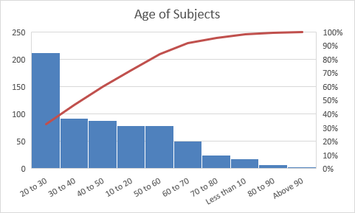

Graph 2 : age of subjects

Among 655 subjects maximum 36% subjects belongs to the age group 20 to 30 years (n=213), 13.4 % subjects belongs to age group 40 to 50 years of age. Remaing all the subjects age group range from 5 to 95 years..

Table Number 3

**Table 5 : Distribution of the Subjects based on** Gender

| Gender | Frequency | Percent |
| --- | --- | --- |
| Male | 295 | 45.03 |
| Female | 360 | 54.9 |
| Total | 655 | 100 |

Graph 3 : Gender

Among 655 subjects maximum 54.9% subjects belongs to female gender (n=360), 45.03 % subjects were Male.

**Table 6 : Distribution of the Subjects based on** Duration of illness

| Duration | Frequency | Percent |
| --- | --- | --- |
| With in 1 years | 173 | 26.4 |
| 1 yr to5 yrs | 247 | 37.7 |
| 5 yrs to 10 yrs | 111 | 16.9 |
| 10yrs to 15 yrs | 41 | 6.25 |
| 15yr to 20yrs | 31 | 4.73 |
| 20yrs to 25yrs | 16 | 2.44 |
| 25yrs to 35yrs | 20 | 3.05 |
| 35yrs to 40yrs | 4 | 0.61 |
| More than 40yrs | 13 | 1.98 |
| Total | 655 | 100 |

Graph 4 : Duration of illness

Among 655 subjects maximum 37.7% (n=247) had a history of illness duration 1 to 5 yrs, 26.4 % subjects has duration of illness with in 1 year (n=173),

**Table 7 : Distribution of the Subjects based on** Complaints

| Symptoms | Frequency | Percent |
| --- | --- | --- |
| COUGH, EXPECTORATION | 152 | 25 |
| Preventive measure | 4 | 0.6 |
| sneezing, cough | 41 | 6.2 |
| SNEEZING | 42 | 6.2 |
| ASTHMA WITH URTICAREA | 2 | 0.3 |
| ASTHMA | 369 | 56 |
| ASTHMA DURING WINTER | 5 | 0.6 |
| ASTHMA ON EXPOSSING TO DUST | 3 | 0.2 |
| ASTHMA WITH COLD | 37 | 5.6 |

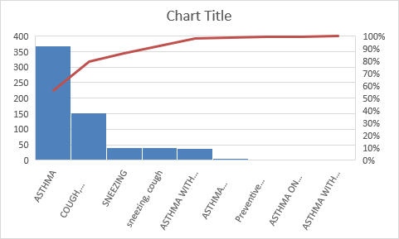

**Graph 5 – Medical history**

Among 655 subjects maximum 56% (n=369) had a history of bronchial asthma, 25 % subjects had history of cough with expectoration (n=152),

**RESULT**

1. **COUGH**

Table number 8 – Cough Before traetment

|  |  |  |  |  |  |  |
| --- | --- | --- | --- | --- | --- | --- |
| **Cough BT** | | **N** | **Mean Rank** | **Sum of Ranks** | **Z Score** | P |
| Cough AT 1 month - Cough BT | Negative Ranks | 271a | 141.55 | 38361 | -15.003 | .001 |
| Positive Ranks | 10b | 126 | 1260 |
| Ties | 374c |  |  |
| Total | 655 |  |  |

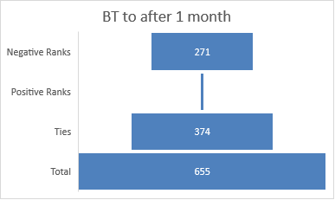

Graph 6 - Cough AT 1 month - Cough BT

Table number 9 – Cough AT 3 Months - Cough BT

|  |  |  |  |  |  |  |
| --- | --- | --- | --- | --- | --- | --- |
| Cough AT 3 Months - Cough BT | Negative Ranks | 409d | 208.41 | 85413.50 | -19.588 | .001 |
| Positive Ranks | 8e | 217.39 | 1740.50 |
| Ties | 238f |  |  |
| Total | 655 |  |  |

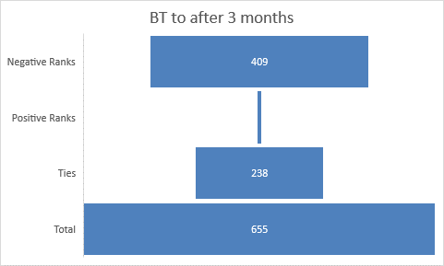

Graph 7 - Cough AT 3 Months - Cough BT

Tbale number 10 - Cough AT 6 Months - Cough BT

|  |  |  |  |  |  |  |
| --- | --- | --- | --- | --- | --- | --- |
| Cough AT 6 Months - Cough BT | Negative Ranks | 308g | 160 | 49583 | -16.328 | .001 |
| Positive Ranks | 14h | 172.86 | 2420 |
| Ties | 333i |  |  |
| Total | 655 |  |  |

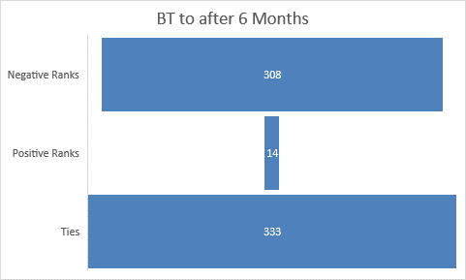

Graph 8 Cough AT 6 Months - Cough BT

|  |  |  |  |  |
| --- | --- | --- | --- | --- |
| Scale | BT | After 1 Month | After 3 Months | After 6 Months |
| No (0) | 126 | 238 | 377 | 482 |
| Mild(1) | 294 | 317 | 233 | 156 |
| Moderate(2) | 177 | 82 | 36 | 11 |
| Sever (3) | 58 | 18 | 9 | 6 |
| Total | 655 | 655 | 655 | 655 |

Graph 9 - Cough : BT After 1 Month After 3 Months After 6 Months

Significant Reduction (p = .001) in the symptom cough of observed among the subjects with the severity of presentation from Bt to After 1 month, Bt to after 3months and BT to after 6 months.

Among the subjects with the severity of presentation of cough before treatment (n=529), was sever (n=6) Moderate (n=11), Mild (n=156) and there was no cough in (n= 482) with in six month of intervention.

Significant Reduction (p = .001) in the symptom cough of observed among the subjects with the severity of presentation mild (n=125), moderate (n=111) and Sever (32) with in six month of intervention.

Table 11 - cough : BT After 1 Month After 3 Months After 6 Months

| **Cough BT** | | | **N** | **Mean Rank** | **Sum of Ranks** | **Z Score** | P |
| --- | --- | --- | --- | --- | --- | --- | --- |
| Mild | Cough AT 1 month - Cough BT | Negative Ranks | 59a | 32.00 | 1888.00 | -6.929b | .001 |
| Positive Ranks | 4b | 32.00 | 128.00 |
| Ties | 113c |  |  |
| Total | 176 |  |  |
| Cough AT 3 Months - Cough BT | Negative Ranks | 109d | 57.00 | 6213.00 | -9.522b | .001 |
| Positive Ranks | 5e | 68.40 | 342.00 |
| Ties | 62f |  |  |
| Total | 176 |  |  |
| Cough AT 6 Months - Cough BT | Negative Ranks | 125g | 64.50 | 8062.50 | -10.115b | .001 |
| Positive Ranks | 5h | 90.50 | 452.50 |
| Ties | 46i |  |  |
| Total | 176 |  |  |
| Moderate | Cough AT 1 month - Cough BT | Negative Ranks | 82a | 41.50 | 3403.00 | -8.616b | .001 |
| Positive Ranks | 0b | .00 | .00 |
| Ties | 35c |  |  |
| Total | 117 |  |  |
| Cough AT 3 Months - Cough BT | Negative Ranks | 110d | 55.50 | 6105.00 | -9.550b | .001 |
| Positive Ranks | 0e | .00 | .00 |
| Ties | 7f |  |  |
| Total | 117 |  |  |
| Cough AT 6 Months - Cough BT | Negative Ranks | 111g | 56.00 | 6216.00 | -9.457b | .001 |
| Positive Ranks | 0h | .00 | .00 |
| Ties | 6i |  |  |
| Total | 117 |  |  |
| Sever | Cough AT 1 month - Cough BT | Negative Ranks | 26a | 13.50 | 351.00 | -4.767b | .001 |
| Positive Ranks | 0b | .00 | .00 |
| Ties | 10c |  |  |
| Total | 36 |  |  |
| Cough AT 3 Months - Cough BT | Negative Ranks | 32d | 16.50 | 528.00 | -5.033b | .001 |
| Positive Ranks | 0e | .00 | .00 |
| Ties | 4f |  |  |
| Total | 36 |  |  |
| Cough AT 6 Months - Cough BT | Negative Ranks | 32g | 16.50 | 528.00 | -5.070b | .001 |
| Positive Ranks | 0h | .00 | .00 |
| Ties | 4i |  |  |
| Total | 36 |  |  |

1. **SPUTUM**

**Table 12 -** Sputum AT 1 month - Sputum BT

|  |  |  |  |  |  |  |
| --- | --- | --- | --- | --- | --- | --- |
| **Sputum BT** | | **N** | **Mean Rank** | **Sum of Ranks** | **Z Score** | P |
| Sputum AT 1 month - Sputum BT | Negative Ranks | 245 | 127.29 | 31187 | -14.837 | .001 |
| Positive Ranks | 8 | 118 | 944 |
| Ties | 402 |  |  |
| Total | 655 |  |  |

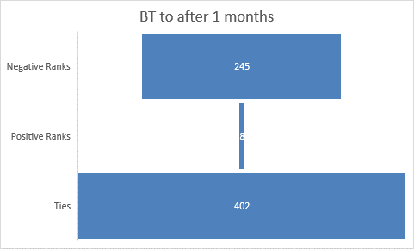

Graph 10 Sputum AT 1 month - Sputum BT

|  |  |  |  |  |  |  |
| --- | --- | --- | --- | --- | --- | --- |
| Sputum AT 3 Months - Sputum BT | Negative Ranks | 354d | 180.88 | 64032.00 | -18.289 | .001 |
| Positive Ranks | 6e | 158.00 | 948.00 |
| Ties | 295f |  |  |
| Total | 655 |  |  |

Tbale 13 - Sputum AT 3 Months - Sputum BT

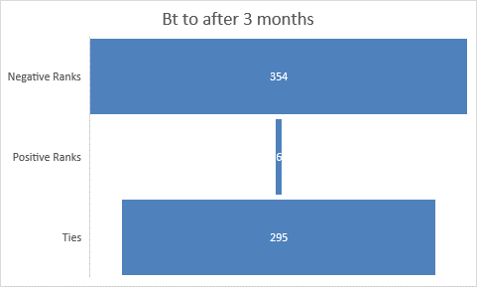

Graph 11 Sputum AT 3 Months - Sputum BT

Tbale 14 - Sputum AT 6 Months - Sputum BT

|  |  |  |  |  |  |  |
| --- | --- | --- | --- | --- | --- | --- |
| Sputum AT 6 Months - Sputum BT | Negative Ranks | 387g | 197.66 | 76494.00 | -19.168 | .001 |
| Positive Ranks | 6h | 154.50 | 927.00 |
| Ties | 262i |  |  |
| Total | 655 |  |  |

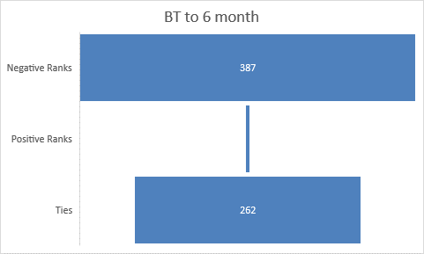

Graph 12 Sputum AT 6 Months - Sputum BT

|  |  |  |  |  |
| --- | --- | --- | --- | --- |
| Scale | BT | After 1 Month | After 3 Months | After 6 Months |
| No (0) | 169 | 325 | 424 | 490 |
| Mild(1) | 337 | 317 | 200 | 149 |
| Moderate(2) | 124 | 82 | 28 | 13 |
| Sever (3) | 25 | 18 | 3 | 3 |
| Total | 655 | 655 | 655 | 655 |

Among the subjects with the severity of presentation of Sputum before treatment (n=486), was sever (n=3) Moderate (n=13), Mild (n=149) and there was no cough in (n= 490) with in six month of intervention.

**Graph 13** Sputum BT After 1 Month After 3 Months After 6 Months

Significant Reduction (p = .001) in the symptom sputum was observed among the subjects with the severity of presentation from Bt to After 1 month, Bt to after 3months and BT to after 6 months.

Significant Reduction (p = .001) in the quantity of sputum was observed among the subjects as 5-20ml (n=143), 20 -50ml(n=82) and more than 50ml (22) with in six month of intervention.

Table 15 - Sputum BT After 1 Month After 3 Months After 6 Months

| **Sputum BT** | | | **N** | **Mean Rank** | **Sum of Ranks** | **Z score** | **p** |
| --- | --- | --- | --- | --- | --- | --- | --- |
| 5-20ml | Sputum AT 1 month - Sputum BT | Negative Ranks | 79a | 42.00 | 3318.00 | -8.232c | .001 |
| Positive Ranks | 4b | 42.00 | 168.00 |
| Ties | 117c |  |  |
| Total | 200 |  |  |
| Sputum AT 3 Months - Sputum BT | Negative Ranks | 122d | 63.00 | 7686.00 | -10.644c | .001 |
| Positive Ranks | 3e | 63.00 | 189.00 |
| Ties | 75f |  |  |
| Total | 200 |  |  |
| Sputum AT 6 Months - Sputum BT | Negative Ranks | 143g | 73.00 | 10439.00 | -11.709c | .001 |
| Positive Ranks | 2h | 73.00 | 146.00 |
| Ties | 55i |  |  |
| Total | 200 |  |  |
| >20-50ml | Sputum AT 1 month - Sputum BT | Negative Ranks | 59a | 30.00 | 1770.00 | -7.173c | .001 |
| Positive Ranks | 0b | .00 | .00 |
| Ties | 26c |  |  |
| Total | 85 |  |  |
| Sputum AT 3 Months - Sputum BT | Negative Ranks | 80d | 40.50 | 3240.00 | -8.118c | .001 |
| Positive Ranks | 0e | .00 | .00 |
| Ties | 5f |  |  |
| Total | 85 |  |  |
| Sputum AT 6 Months - Sputum BT | Negative Ranks | 82g | 41.50 | 3403.00 | -8.126c | .001 |
| Positive Ranks | 0h | .00 | .00 |
| Ties | 3i |  |  |
| Total | 85 |  |  |
| >50ml | Sputum AT 1 month - Sputum BT | Negative Ranks | 8a | 4.50 | 36.00 | -2.714c | .007 |
| Positive Ranks | 0b | .00 | .00 |
| Ties | 6c |  |  |
| Total | 14 |  |  |
| Sputum AT 3 Months - Sputum BT | Negative Ranks | 12d | 6.50 | 78.00 | -3.169c | .002 |
| Positive Ranks | 0e | .00 | .00 |
| Ties | 2f |  |  |
| Total | 14 |  |  |
| Sputum AT 6 Months - Sputum BT | Negative Ranks | 12g | 6.50 | 78.00 | -3.109c | .002 |
| Positive Ranks | 0h | .00 | .00 |
| Ties | 2i |  |  |
| Total | 14 |  |  |

1. Dyspnea

Table 16 – Dyspnea : Negative ranks , positive ranks , ties

|  |  |  |  |  |  |
| --- | --- | --- | --- | --- | --- |
| Dyspnea | N | Mean Rank | Sum of Ranks | z | p |
| Negative Ranks | | 220a | 113.75 | 25024.00 | -13.805 | 0.001 |
| Positive Ranks | | 6b | 104.50 | 627.00 |
| Ties | | 429c |  |  |
| Total | | 655 |  |  |

Graph 14 Dyspnea : Negative ranks , positive ranks , ties

Tbale 17 - Dyspnoea AT 3 Months - Dyspnoea BT

|  |  |  |  |  |  |  |
| --- | --- | --- | --- | --- | --- | --- |
| Dyspnoea AT 3 Months - Dyspnoea BT | Negative Ranks | 309d | 158.54 | 48990.00 | -16.062 | 0.001 |
| Positive Ranks | 6e | 130.00 | 780.00 |
| Ties | 340f |  |  |
| Total | 655 |  |  |

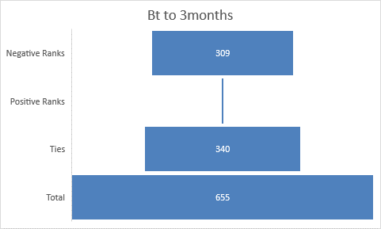

Graph 15 Dyspnoea AT 3 Months - Dyspnoea BT

Table 18 - Dyspnoea AT 6 Months - Dyspnoea BT

|  |  |  |  |  |  |  |
| --- | --- | --- | --- | --- | --- | --- |
| Dyspnoea AT 6 Months - Dyspnoea BT | Negative Ranks | 342g | 173.99 | 59503.00 | -16.801 | 0.001 |
| Positive Ranks | 4h | 132.00 | 528.00 |
| Ties | 309i |  |  |
| Total | 655 |  |  |

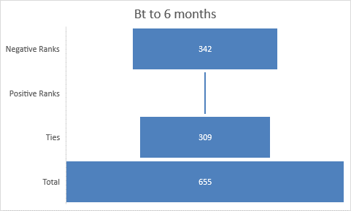

Graph 16 Dyspnoea AT 6 Months - Dyspnoea BT

|  |  |  |  |  |
| --- | --- | --- | --- | --- |
| Scale | BT | After 1 Month | After 3 Months | After 6 Months |
| No (0) | 217 | 349 | 433 | 487 |
| Mild(1) | 284 | 231 | 182 | 138 |
| Moderate(2) | 117 | 61 | 33 | 29 |
| Sever (3) | 37 | 14 | 7 | 1 |
| Total | 655 | 655 | 655 | 655 |

Among the subjects with the severity of presentation of Dyspnea before treatment (n=438), was sever (n=1) Moderate (n=29), Mild (n=138) and there was no cough in (n= 487) with in six month of intervention.

Graph 17 Dyspnea BT After 1 Month After 3 Months After 6 Months

Significant Reduction (p = .001) in the symptom Dyspneawas observed among the subjects with the severity of presentation from Bt to After 1 month, Bt to after 3months and BT to after 6 months.

Significant Reduction (p = .001) in the symptom dyspnea was observed among the subjects with the severity of presentation breathlessness walk up straight hill (n=103), breathlessness on ground level (n=62) and room walk, leave house, dress or undress (22) with in six month of intervention.

Table 19 - Dyspnea BT After 1 Month After 3 Months After 6 Months

| Dyspnea BT | | | N | Mean Rank | Sum of Ranks | z | p |
| --- | --- | --- | --- | --- | --- | --- | --- |
| breathlessness walk up straight hill | Dyspnoea AT 1 month - Dyspnoea BT | Negative Ranks | 55a | 29.50 | 1622.50 | -6.828b | 0.001 |
| Positive Ranks | 3b | 29.50 | 88.50 |
| Ties | 94c |  |  |
| Total | 152 |  |  |
| Dyspnoea AT 3 Months - Dyspnoea BT | Negative Ranks | 84d | 44.00 | 3696.00 | -8.684b | 0.001 |
| Positive Ranks | 3e | 44.00 | 132.00 |
| Ties | 65f |  |  |
| Total | 152 |  |  |
| Dyspnoea AT 6 Months - Dyspnoea BT | Negative Ranks | 103g | 53.00 | 5459.00 | -9.806b | 0.001 |
| Positive Ranks | 2h | 53.00 | 106.00 |
| Ties | 47i |  |  |
| Total | 152 |  |  |
| breathlessness on ground level | Dyspnoea AT 1 month - Dyspnoea BT | Negative Ranks | 47a | 24.00 | 1128.00 | -6.474b | 0.001 |
| Positive Ranks | 0b | .00 | .00 |
| Ties | 25c |  |  |
| Total | 72 |  |  |
| Dyspnoea AT 3 Months - Dyspnoea BT | Negative Ranks | 61d | 31.00 | 1891.00 | -7.091b | 0.001 |
| Positive Ranks | 0e | .00 | .00 |
| Ties | 11f |  |  |
| Total | 72 |  |  |
| Dyspnoea AT 6 Months - Dyspnoea BT | Negative Ranks | 62g | 31.50 | 1953.00 | -7.066b | 0.001 |
| Positive Ranks | 0h | .00 | .00 |
| Ties | 10i |  |  |
| Total | 72 |  |  |
| room walk, leave house, dress or undress | Dyspnoea AT 1 month - Dyspnoea BT | Negative Ranks | 15a | 8.00 | 120.00 | -3.690b | 0.001 |
| Positive Ranks | 0b | .00 | .00 |
| Ties | 8c |  |  |
| Total | 23 |  |  |
| Dyspnoea AT 3 Months - Dyspnoea BT | Negative Ranks | 19d | 10.00 | 190.00 | -3.905b | 0.001 |
| Positive Ranks | 0e | .00 | .00 |
| Ties | 4f |  |  |
| Total | 23 |  |  |
| Dyspnoea AT 6 Months - Dyspnoea BT | Negative Ranks | 22g | 11.50 | 253.00 | -4.174b | 0.001 |
| Positive Ranks | 0h | .00 | .00 |
| Ties | 1i |  |  |
| Total | 23 |  |  |

1. Ronchi

**Table 20 – Ronchi: Positive ranks , negative ranks , ties**

|  |  |  |  |  |  |  |  |
| --- | --- | --- | --- | --- | --- | --- | --- |
| Ronchi BT | | | N | Mean Rank | Sum of Ranks | Z | p |
|  | Ronchi AT 1 month - Ronchi BT | Negative Ranks | 94a | 49.19 | 4624.00 | -8.856 | 0.001 |
| Positive Ranks | 3b | 43.00 | 129.00 |
| Ties | 558c |  |  |
| Total | 655 |  |  |

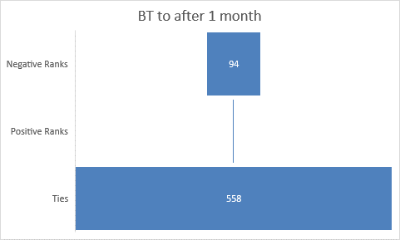

Graph 18  **Ronchi : Positive ranks , negative ranks , ties**

Table 21 - Ronchi AT 3 month - Ronchi BT

|  |  |  |  |  |  |  |
| --- | --- | --- | --- | --- | --- | --- |
| Ronchi AT 3 month - Ronchi BT | Negative Ranks | 138d | 71.88 | 9919.00 | -10.611 | 0.001 |
| Positive Ranks | 4e | 58.50 | 234.00 |
| Ties | 513f |  |  |
| Total | 655 |  |  |

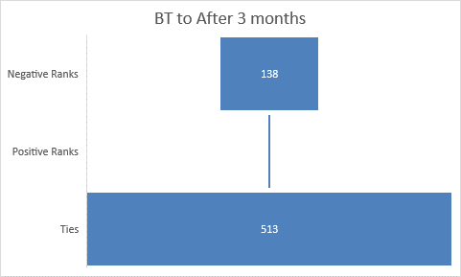

Graph 19 Ronchi AT 3 month - Ronchi BT

Table 22 - Ronchi AT 6 Months - Ronchi BT

|  |  |  |  |  |  |  |
| --- | --- | --- | --- | --- | --- | --- |
| Ronchi AT 6 Months - Ronchi BT | Negative Ranks | 152g | 82.91 | 12603.00 | -10.099 | 0.001 |
| Positive Ranks | 12h | 77.25 | 927.00 |
| Ties | 491i |  |  |
| Total | 655 |  |  |

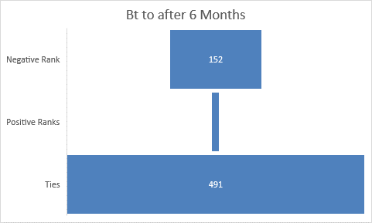

Graph 20 Ronchi AT 6 Months - Ronchi BT

|  |  |  |  |  |
| --- | --- | --- | --- | --- |
| Scale | BT | After 1 Month | After 3 Months | After 6 Months |
| No (0) | 447 | 501 | 544 | 563 |
| Mild(1) | 133 | 121 | 89 | 70 |
| Moderate(2) | 59 | 24 | 16 | 16 |
| Sever (3) | 16 | 9 | 6 | 6 |
| Total | 655 | 655 | 655 | 655 |

Graph 21 Ronchi : BT After 1 Month After 3 Months After 6 Months

Among the subjects with the severity of presentation of Ronchi before treatment (n=208), was sever (n=6) Moderate (n=16), Mild (n=70) and there was no cough in (n= 563) with in six month of intervention.

Significant Reduction (p = .001) in the symptom Ronchi was observed among the subjects with the severity of presentation from Bt to After 1 month, Bt to after 3months and BT to after 6 months.

Significant Reduction (p = .001) in the symptom ronchi was observed among the subjects with the severity of presentation in one side or in 1-2 auscultator area (n=52), Room side or 4-5 area (n=39) and present all (n=7) with in six month of intervention.

Table 23 – Ronchi : BT After 1 Month After 3 Months After 6 Months

| **Ronchi BT** | | | **N** | **Mean Rank** | **Sum of Ranks** | **Z Score** | **P Value** |
| --- | --- | --- | --- | --- | --- | --- | --- |
| one side or in 1-2 auscultatory area | Ronchi AT 1 month - Ronchi BT | Negative Ranks | 22a | 11.50 | 253.00 | -4.690c | .001 |
| Positive Ranks | 0b | .00 | .00 |
| Ties | 63c |  |  |
| Total | 85 |  |  |
| Ronchi AT 3 Months - Ronchi BT | Negative Ranks | 41d | 21.50 | 881.50 | -6.172c | .001 |
| Positive Ranks | 1e | 21.50 | 21.50 |
| Ties | 43f |  |  |
| Total | 85 |  |  |
| Ronchi AT 6 Months - Ronchi BT | Negative Ranks | 52g | 27.00 | 1404.00 | -7.005c | .001 |
| Positive Ranks | 1h | 27.00 | 27.00 |
| Ties | 32i |  |  |
| Total | 85 |  |  |
| oones side or 4-5 area | Ronchi AT 1 month - Ronchi BT | Negative Ranks | 29a | 15.60 | 452.50 | -4.833c | .001 |
| Positive Ranks | 1b | 12.50 | 12.50 |
| Ties | 14c |  |  |
| Total | 44 |  |  |
| Ronchi AT 3 Months - Ronchi BT | Negative Ranks | 38d | 20.18 | 767.00 | -5.468c | .001 |
| Positive Ranks | 1e | 13.00 | 13.00 |
| Ties | 5f |  |  |
| Total | 44 |  |  |
| Ronchi AT 6 Months - Ronchi BT | Negative Ranks | 39g | 20.00 | 780.00 | -5.719c | .001 |
| Positive Ranks | 0h | .00 | .00 |
| Ties | 5i |  |  |
| Total | 44 |  |  |
| preseant all | Ronchi AT 1 month - Ronchi BT | Negative Ranks | 5a | 3.00 | 15.00 | -2.121c | .031 |
| Positive Ranks | 0b | .00 | .00 |
| Ties | 4c |  |  |
| Total | 9 |  |  |
| Ronchi AT 3 Months - Ronchi BT | Negative Ranks | 7d | 4.00 | 28.00 | -2.460c | .008 |
| Positive Ranks | 0e | .00 | .00 |
| Ties | 2f |  |  |
| Total | 9 |  |  |
| Ronchi AT 6 Months - Ronchi BT | Negative Ranks | 7g | 4.00 | 28.00 | -2.428c | .008 |
| Positive Ranks | 0h | .00 | .00 |
| Ties | 2i |  |  |
| Total | 9 |  |  |

1. Crepitation

Table 24 - Crepitations AT 1 month - Crepitations BT

|  |  |  |  |  |  |  |  |
| --- | --- | --- | --- | --- | --- | --- | --- |
| Crepitations | | | N | Mean Rank | Sum of Ranks | Z | p |
|  | Crepitations AT 1 month - Crepitations BT | Negative Ranks | 128a | 64.50 | 8256.00 | -11.149 | 0.001 |
| Positive Ranks | 0b | .00 | .00 |
| Ties | 527c |  |  |
| Total | 655 |  |  |

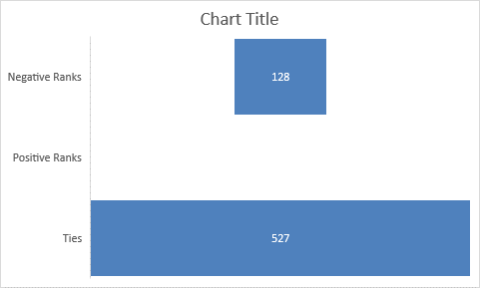

Graph 22 Crepitations AT 1 month - Crepitations BT

Table 25 - Crepitations AT 3 month - Crepitations BT

|  |  |  |  |  |  |  |
| --- | --- | --- | --- | --- | --- | --- |
| Crepitations AT 3 month - Crepitations BT | Negative Ranks | 171d | 88.82 | 15188.50 | -11.975 | 0.001 |
| Positive Ranks | 5e | 77.50 | 387.50 |
| Ties | 479f |  |  |
| Total | 655 |  |  |

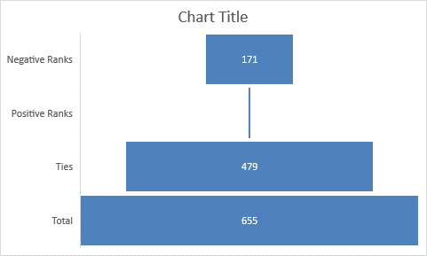

Graph 23 Crepitations AT 3 month - Crepitations BT

Table 26 - Crepitations AT 6 month - Crepitations BT

|  |  |  |  |  |  |  |
| --- | --- | --- | --- | --- | --- | --- |
| Crepitations AT 6 month - Crepitations BT | Negative Ranks | 182g | 94.44 | 17188.00 | -12.036 | 0.001 |
| Positive Ranks | 5h | 78.00 | 390.00 |
| Ties | 468i |  |  |
| Total | 655 |  |  |

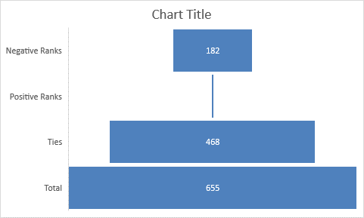

Graph 24 Crepitations AT 6 month - Crepitations BT

|  |  |  |  |  |
| --- | --- | --- | --- | --- |
| Scale | BT | After 1 Month | After 3 Months | After 6 Months |
| No (0) | 430 | 529 | 575 | 593 |
| Mild(1) | 176 | 104 | 66 | 51 |
| Moderate(2) | 41 | 18 | 12 | 11 |
| Sever (3) | 8 | 4 | 2 | 0 |
| Total | 655 | 655 | 655 | 655 |

Graph 25 Crepitations : BT After 1 Month After 3 Months After 6 Months

Among the subjects with the severity of presentation of Crepitation before treatment (n=225), was sever (n=0) Moderate (n=11, Mild (n=51) and there was no cough in (n= 593) with in six month of intervention.

Significant Reduction (p = .001) in the symptom Crepitation was observed among the subjects with the severity of presentation from Bt to After 1 month, Bt to after 3months and BT to after 6 months.

Significant Reduction (p = .001) in the symptom crepitation was observed among the subjects with the severity of presentation in one side or in 1-2 auscultator area (n=80), Room side or 4-5 area (n=32) and present all (n=5) with in six month of intervention.

Table 27 - Crepitations : BT After 1 Month After 3 Months After 6 Months

| **Crepitation BT** | | | **N** | **Mean Rank** | **Sum of Ranks** | **Z score** | p |
| --- | --- | --- | --- | --- | --- | --- | --- |
| one side or in 1-2 auscultatory area | Crepitations AT 1 month - Crepitations BT | Negative Ranks | 54a | 27.50 | 1485.00 | -7.348c |  |
| Positive Ranks | 0b | .00 | .00 |
| Ties | 56c |  |  |
| Total | 110 |  |  |
| Crepitations AT 3 Months - Crepitations BT | Negative Ranks | 74d | 38.50 | 2849.00 | -8.259c |  |
| Positive Ranks | 2e | 38.50 | 77.00 |
| Ties | 34f |  |  |
| Total | 110 |  |  |
| Crepitations AT 6 Months - Crepitations BT | Negative Ranks | 80g | 41.50 | 3320.00 | -8.614c |  |
| Positive Ranks | 2h | 41.50 | 83.00 |
| Ties | 28i |  |  |
| Total | 110 |  |  |
| Room side or 4-5 area | Crepitations AT 1 month - Crepitations BT | Negative Ranks | 23a | 12.00 | 276.00 | -4.564c |  |
| Positive Ranks | 0b | .00 | .00 |
| Ties | 11c |  |  |
| Total | 34 |  |  |
| Crepitations AT 3 Months - Crepitations BT | Negative Ranks | 31d | 16.00 | 496.00 | -5.015c |  |
| Positive Ranks | 0e | .00 | .00 |  |
| Ties | 3f |  |  |  |
| Total | 34 |  |  |  |
| Crepitations AT 6 Months - Crepitations BT | Negative Ranks | 32g | 16.50 | 528.00 | -5.160c |  |
| Positive Ranks | 0h | .00 | .00 |  |
| Ties | 2i |  |  |  |
| Total | 34 |  |  |  |
| present all | Crepitations AT 1 month - Crepitations BT | Negative Ranks | 3a | 2.00 | 6.00 | -1.632 |  |
| Positive Ranks | 0b | .00 | .00 |  |
| Ties | 2c |  |  |  |
| Total | 5 |  |  |  |
| Crepitations AT 3 Months - Crepitations BT | Negative Ranks | 4d | 2.50 | 10.00 |  |  |
| Positive Ranks | 0e | .00 | .00 |  |  |
| Ties | 1f |  |  |  |  |
| Total | 5 |  |  |  |  |
| Crepitations AT 6 Months - Crepitations BT | Negative Ranks | 5g | 3.00 | 15.00 |  |  |
| Positive Ranks | 0h | .00 | .00 |  |  |
| Ties | 0i |  |  |  |  |
| Total | 5 |  |  |  |  |

**DISCUSSION**

Drug administration in specific time in specific dosage and in specific form is one of the evolvedconcepts of Ayurveda. Because drug in specific form has different action and with anupana (vehicle of drug administration it acts in the different way). In this disease Vata moves in the reverse order and pervades the channels afflicting the neck and head, and stimulates Kapha to cause signs and symptoms due to obstruction. Hence the therapies will be beneficial which induce downward movement of Vata just like the snow melts on account of the hot rays of the sun, the stable Kapha in the body gets dissolved on account of the heat generated by oleation and fomentation therapies. That liquefied Kapha should be eliminated by administering emesis therapy. And also the residual Dosha which are still remaining in channels can be eliminated by the administering medicated fumes

Significant Reduction (p = .001) in the symptom cough of observed among the subjects with the severity of presentation from Bt to After 1 month, Bt to after 3months and BT to after 6 months.Among the subjects with the severity of presentation of cough before treatment (n=529), was sever (n=6) Moderate (n=11), Mild (n=156) and there was no cough in (n= 482) with in six month of intervention.Significant Reduction (p = .001) in the symptom cough of observed among the subjects with the severity of presentation mild (n=125), moderate (n=111) and Sever (32) with in six month of intervention. After intervention the subjects who are presented with cough observed reduction form severe to mild.

Similarly among the subjects with the severity of presentation of Sputum before treatment (n=486), was sever (n=3) Moderate (n=13), Mild (n=149) and there was no cough in (n= 490) with in six month of intervention. Significant Reduction (p = .001) in the symptom sputum was observed among the subjects with the severity of presentation from Bt to After 1 month, Bt to after 3months and BT to after 6 months.

Significant Reduction (p = .001) in the quantity of sputum was observed among the subjects as 5-20ml (n=143), 20 -50ml(n=82) and more than 50ml (22) with in six month of intervention.

According to the Samanya – Vishesa principle, Pippali with the opposite Gunas like Katu Rasa, Laghu, and Tikshna Guna, causes alleviation of Kapha Dosha, with opposite properties like Madhura, Guru, Manda, and so on, of Kapha Dosha. Pippali with Tikshna Guna causes Bhedana of Kapha, which is stuck to the Srotasa by Picchila and Sandra Guna. Once the Dosha is separated from the Srotasa, the Ushna Guna of the drug causes Vilayana of Kapha and generates easy expectoration. Kaphasthivana causes Srotoshuddhi, and hence, Vata Sanga and Vimarga-gamana are corrected. That leads to Vyadhi Shamana. As Maricha has Katu Rasa, Katu Vipak, Tikshna, Rukshna and Laghu guna it does Kaphanissaran and Kaphashoshana and does Agneedeepan. Thus effective in Kaphaja Kasa. Studies have revealed recently that the active content piperine influences enzymes leading to detoxification, enhancement of the absorption and bioavailability of herbal and conventional drugs

Among the subjects with the severity of presentation of Dyspnea before treatment (n=438), was sever (n=1) Moderate (n=29), Mild (n=138) and there was no cough in (n= 487) with in six month of intervention. Significant Reduction (p = .001) in the symptom Dyspneawas observed among the subjects with the severity of presentation from Bt to After 1 month, Bt to after 3months and BT to after 6 months.

Significant Reduction (p = .001) in the symptom dyspnea was observed among the subjects with the severity of presentation breathlessness walk up straight hill (n=103), breathlessness on ground level (n=62) and room walk, leave house, dress or undress (22) with in six month of intervention. Among the subjects with the severity of presentation of Ronchi before treatment (n=208), was sever (n=6) Moderate (n=16), Mild (n=70) and there was no cough in (n= 563) with in six month of intervention.

Significant Reduction (p = .001) in the symptom Ronchi was observed among the subjects with the severity of presentation from Bt to After 1 month, Bt to after 3months and BT to after 6 months. Significant Reduction (p = .001) in the symptom ronchi was observed among the subjects with the severity of presentation in one side or in 1-2 auscultator area (n=52), Room side or 4-5 area (n=39) and present all (n=7) with in six month of intervention.

Among the subjects with the severity of presentation of Crepitation before treatment (n=225), was sever (n=0) Moderate (n=11, Mild (n=51) and there was no cough in (n= 593) with in six month of intervention. Significant Reduction (p = .001) in the symptom Crepitation was observed among the subjects with the severity of presentation from Bt to After 1 month, Bt to after 3months and BT to after 6 months. Significant Reduction (p = .001) in the symptom crepitation was observed among the subjects with the severity of presentation in one side or in 1-2 auscultator area (n=80), Room side or 4-5 area (n=32) and present all (n=5) with in six month of intervention

Here in this formulation pippali and marich fine powder was administered in the banana which acted as vehicle to carry the pungent powders of the drugs. Both these drugs well known for its action on respiratory system in many pharmacological studies.Based on modern cell, animal, and human studies, piperine has been found to have immunomodulatory, anti-oxidant, anti-asthmatic, anti-carcinogenic, anti-inflammatory, anti-ulcer, and anti-amoebic properties(Meghwal M1, GoswamiTK.Pipernigrum and piperine: an update.Phytother Res. 2013 Aug;27(8):1121-30. <https://www.ncbi.nlm.nih.gov/pubmed/23625885>.

[Piper longum](https://www.sciencedirect.com/topics/pharmacology-toxicology-and-pharmaceutical-science/piper-longum) (family Pipperaceae) is used as an important traditional medicine in Asia and the Pacific islands. Piper longum has been reported as a good remedy for treating [tuberculosis](https://www.sciencedirect.com/topics/pharmacology-toxicology-and-pharmaceutical-science/tuberculosis) and [respiratory tract infections](https://www.sciencedirect.com/topics/pharmacology-toxicology-and-pharmaceutical-science/respiratory-tract-infection) (Singh, 1992). The fruits and roots of this plant have been used in the treatment of childhood asthma (Dahanukar et al., 1984; Fernandez et al., 1980). The alcoholic extract of P. longum fruits showed immunomodulatory potential in experimental animal studies (Sunila and Kuttan, 2004). [Piperine](https://www.sciencedirect.com/topics/pharmacology-toxicology-and-pharmaceutical-science/piperine) is a major alkaloid isolated from the P. longum fruits and has been reported to inhibit the release of Th-2-mediated cytokines, eosinophil infiltration, and airway hyper-responsiveness in an ovalbumin-induced asthma model (Kim and Lee, 2009).

Piper nigrum Linn. belongs to the family [*Piperaceae*](https://www.sciencedirect.com/topics/biochemistry-genetics-and-molecular-biology/piperaceae) and its dried unripe fruit is used commonly as “black pepper.” This perennial shrub is indigenous to the Western coasts of India and tropical parts of Asia.

[Phytochemical](https://www.sciencedirect.com/topics/biochemistry-genetics-and-molecular-biology/phytochemical) studies on black pepper have determined the presence of various minerals, vitamins (β-carotenes, [tocopherols](https://www.sciencedirect.com/topics/chemistry/vitamin-e), [ascorbic acid](https://www.sciencedirect.com/topics/chemistry/ascorbic-acid), [thiamine](https://www.sciencedirect.com/topics/chemistry/thiamine), [riboflavin](https://www.sciencedirect.com/topics/chemistry/riboflavin) and niacin), [polysaccharides](https://www.sciencedirect.com/topics/chemistry/polysaccharide) (arabinose, [rhamnose](https://www.sciencedirect.com/topics/chemistry/rhamnose), galacturic acid), sterols (β-sitosterol, [terpenoids](https://www.sciencedirect.com/topics/chemistry/terpenoid), sesquiterpenes), fatty acids (linoleic acid), volatile oils (camphenes, pinenes), [alkaloids](https://www.sciencedirect.com/topics/chemistry/alkaloid) (piperine, [piperidine](https://www.sciencedirect.com/topics/chemistry/piperidine), piperolein, [capsaicin](https://www.sciencedirect.com/topics/chemistry/capsaicin), 2-dihydrocaspaicin), resins (chavicin), organic acids (hexadecanoic acid, octadecanoic acid), amides (pipnoohine, pipyahyine, guineensine, pipericide) and various [phenolic compounds](https://www.sciencedirect.com/topics/chemistry/phenolic-compound) (benzamides, [gallic acid](https://www.sciencedirect.com/topics/chemistry/gallic-acid), [kaempferol](https://www.sciencedirect.com/topics/chemistry/kaempferol), [coumarins](https://www.sciencedirect.com/topics/chemistry/coumarin), quercetin) ([Duke, 1992](https://www.sciencedirect.com/science/article/pii/S1756464615004235" \l "bib0045), [Siddiqui et al, 2004](https://www.sciencedirect.com/science/article/pii/S1756464615004235" \l "bib0180), [Siddiqui et al, 2005](https://www.sciencedirect.com/science/article/pii/S1756464615004235" \l "bib0185)). Piperine, the active principle of black pepper, has been found to possess anti-inflammatory ([Mujumdar, Dhuley, Deshmukh, Raman, & Naik, 1990](https://www.sciencedirect.com/science/article/pii/S1756464615004235" \l "bib0115)), anti-convulsant ([D'Hooge et al., 1996](https://www.sciencedirect.com/science/article/pii/S1756464615004235" \l "bib0035)), [hypoglycaemic](https://www.sciencedirect.com/topics/chemistry/antidiabetic-agent) ([Panda & Kar, 2003](https://www.sciencedirect.com/science/article/pii/S1756464615004235" \l "bib0130)), immunomodulatory ([Sunila & Kuttan, 2004](https://www.sciencedirect.com/science/article/pii/S1756464615004235" \l "bib0195)), anti-depressant ([Lee et al., 2005](https://www.sciencedirect.com/science/article/pii/S1756464615004235" \l "bib0095)), vasomodulatory ([Taqvi, Shah, & Gilani, 2008](https://www.sciencedirect.com/science/article/pii/S1756464615004235" \l "bib0200)), bioavailability-enhancing ([Veda & Srinivasan, 2009](https://www.sciencedirect.com/science/article/pii/S1756464615004235" \l "bib0215)), anti-spasmodic ([Mehmood & Gilani, 2010](https://www.sciencedirect.com/science/article/pii/S1756464615004235" \l "bib0100)), anti-hyperlipidaemic ([Chen, Ma, Liang, Peng, & Zuo, 2011](https://www.sciencedirect.com/science/article/pii/S1756464615004235" \l "bib0030)), insecticidal ([Park, 2012](https://www.sciencedirect.com/science/article/pii/S1756464615004235" \l "bib0135)), anti-tumour ([Do et al., 2013](https://www.sciencedirect.com/science/article/pii/S1756464615004235" \l "bib0040)), cardioprotective ([Dutta et al., 2014](https://www.sciencedirect.com/science/article/pii/S1756464615004235" \l "bib0055)) and anti-oxidant ([Embuscado, 2015](https://www.sciencedirect.com/science/article/pii/S1756464615004235" \l "bib0060)) properties. More recently, novel compounds isolated from black peppercorns have been found to possess [larvicidal](https://www.sciencedirect.com/topics/chemistry/larvicidal) activity against Aides egypti, the principle vector of [dengue virus](https://www.sciencedirect.com/topics/biochemistry-genetics-and-molecular-biology/dengue-virus) ([Santiago, Alvero, & Villaseñor, 2015](https://www.sciencedirect.com/science/article/pii/S1756464615004235" \l "bib0160)).

Besides being used as a spice, black pepper enjoys folkloric reputation for use in airway disorders including bronchitis and asthma ([Duke et al, 2002](https://www.sciencedirect.com/science/article/pii/S1756464615004235" \l "bib0050), [Kapoor, 1990](https://www.sciencedirect.com/science/article/pii/S1756464615004235" \l "bib0085), [Usmanghani et al, 1997](https://www.sciencedirect.com/science/article/pii/S1756464615004235" \l "bib0210)). Currently, no scientific evidence is available to support its use in respiratory disorders. We hypothesized that black pepper may contain certain bioactive constituents that can cause [bronchodilation](https://www.sciencedirect.com/topics/biochemistry-genetics-and-molecular-biology/bronchodilatation). As black pepper is consumed heavily throughout the world, precipitation or relief of bronchospasm by its chemical constituents can have important [nutraceutical](https://www.sciencedirect.com/topics/chemistry/nutraceutical) implications.

As per the opinion of folklore practitioner Bananas may be beneficial for people with chronic obstructive pulmonary disease (COPD). They are potassium-rich and contain antioxidants and fiber. An [older studyTrusted Source](https://www.ncbi.nlm.nih.gov/pmc/articles/PMC5559148/) examining over 2,000 participants with COPD in a specific cohort found those who ate bananas had better lung function measures over a 3-year period. The research associated bananas with better clinical outcomes, including less emphysema, walking scores, and forced expiratory volume — how much air a person can exhale during a forced breath.

A [2020 studyTrusted Source](https://www.ncbi.nlm.nih.gov/pmc/articles/PMC7544412/) of 81 patients with acute exacerbations of COPD found that potassium levels are lower in these people compared to controls. The study also associated lower potassium levels with higher death rates in COPD patients.

According to a [2022 studyTrusted Source](https://bmcemergmed.biomedcentral.com/articles/10.1186/s12873-022-00607-7), 16% of patients presenting to the emergency room with exacerbation of COPD have low potassium, which doctors call [hypokalemia](https://www.medicalnewstoday.com/articles/324245). However, the study authors did not find an association between hypokalemia and adverse outcomes in patients presenting with an acute exacerbation of COPD.

Therefore, including bananas in the diet may be helpful. One [banana](https://www.medicalnewstoday.com/articles/271157) contains 375 milligrams of potassium, providing [8%Trusted Source](https://fdc.nal.usda.gov/fdc-app.html#/food-details/1105314/nutrients) of the Daily Value (DV) of potassium — how much a nutrient in one serving of food contributes to the recommended [DVTrusted Source](https://www.fda.gov/food/new-nutrition-facts-label/daily-value-new-nutrition-and-supplement-facts-labels) of the nutrient.

However, another [2019 study](https://erj.ersjournals.com/content/54/suppl_63/PA4334) indicates [high potassium levels (hyperkalemia)](https://www.medicalnewstoday.com/articles/324913) were only present in 6.7% of all people with COPD. Although some of these cases may be due to the medications which raised potassium levels, it may be sensible not to overeat bananas.

41% of COPD patients with hyperkalemia were taking medications that may potentially have raised potassium levels. Therefore, it may be sensible to eat bananas in moderation, as with all other foods.

A [study from 2021Trusted Source](https://www.ncbi.nlm.nih.gov/pmc/articles/PMC8577879/) suggests that people who eat an antioxidant-rich diet have higher [lung function scores](https://www.medicalnewstoday.com/articles/305190).

**CONCLUSION**

**Single Dose (Anubhoota Yoga) of Pippali(*piper longa*) and Marica( *piper nigrum* )in Banana on Mrighashira Poornima is effective in reducing the Pranavaha Sroto Dusti Vikaras Vis – A- Viz Respiratory Disorders**). In this study seviourity of the upper and lower respiratory infection symptoms severity was reduced. How ever Tamakashvasa being Yapya VYadhi here complete remission of the disease is not possible.

How ever the anubhootha yoga signle intervention on mrigha shir nakstar is giving a significant result in reducing the symptoms thamak swasa and other respitatory disorders and the same results is found by the researcher after six months of follow up

The results were not only clinically significant but from the pont patient satificaion the ontervention is higky appreciated by the patients and the relatives if the patientand the same intervention is givern in many ceneters all over the Karnataka which shows its universally acceotabce in the community the above intervevntion is given since many years by the cacdemically qualified doctors in many areas where they are giving it for the years because of its efficacy in respiratory dis orders by seeing all these phenomena we conclude that the intervention is really wonderful not only because it is validated and documented I this project but it is practiced for many years and widely accepeted as a succefful remedy by the ayrveda fratetenity and also accepeted by the community.

**SUMMARY**

The study titled **A SIGNLE ARM MULTICENTRE STUDY TO ANALYZE THE EFFECT OF SINGLE DOSE ( ANUBHOOTA YOGA) OF PIPPALI(*PIPER LONGA*) AND MARICA( *PIPER NIGRUM* )IN BANANA ON MRIGHASHIRA POORNIMA IN PRANAVAHA SROTO DUSTI VIKARAS VIS – A- VIZ RESPIRATORY DISORDERS.**

Was conducted. It was a study was an open label randomized single arm Pre-test and Post-test design of 655 subjects to clinically and scientifically evaluate the effect of local health tradition of pippali and marica fro respiratory didorders. In a multicentric methodology.

As a part of multicentric methodology is given on the mrighashira nakshthra at 3 different places one at mysore in a health facility near vidyaranya puram under the guidance of DR A S Chandra shekar , the second location was a institution in Hassan SDM and the third location was a govermnet ayurveda dispensary in arakalagudu . So with this three locations same day for the different subjects of different geographical area at the same time is given by different doctors for respiratory disorders and the interventions were same and assessment parameters are same . Thus a platform is created to make the study multicentric .

Ayurveda has procedures for administration of medicine explicit to time. It considers time as the one which brings appropriateness of medicine as well as makes the medicine more effective (baishajyayogyakritcavi 8/). Therefore it is essential to administer the medicine considering six different factors for effective administration of a given formulation specific to time .They are day, night, drug administration time,season, time of food intake and as well as place of administration (ca ci 30/). But in this study the administration time is based on a particular nakshtra with a different launching vehicle and the speciality of the administration is once in a year irrespective of severity of the disease and the above type of administration is not at all seen in any of ayurvedic classics but the classical administration explained by sharangadara that is dasha vida oushadha kala does not explain the above ttype of administration which is a tribal input different type administration for which validation is a must however the above type of administration if found valid can help to cure many respiratory disorders is a miraculous way because it is a simple acceptable and only one time dosage that is why the project has designed for the above protocol and the results are satisfactory and validated both clinically and statistically in the designed protocol.

Proper breathing is essential for good health. Breathing brings both oxygen and the vitality to every cell in the body. Shortness of breath, cough are those common health complains which everyone experience throughout their life with different magnitude. Such complains are found in every age group and in due course of time turn out be difficult to survive with. A traditional formulation is in practice in the southern part of karnattaka for respiratory complaints. Wherein they administer pippali and marica to the recurrent respiratory complaints on the specific full moon day of mrigashira month( November and December ),that is in the beginning of winter as a single dose medicine. User’s feedback on this practice was encouraging, as single administration could give them a relief for whole year from repeated attacks of cold cough and running nose and in some cases single dose prevented from further attacks of wheezing. Hence considering these aspects a multicentric clinical evaluation of the formulation was planned by the assistant director government research center Mysore. Accordingly study was conducted in three different institutes in southern part of Karnataka.

First part of this study comprises of the contents like review of literature of the contents like pippali, marica, ayurveda , mrigha shira nakshtra. It deals with the pippali and marica and its historical use among tribals and its drug review . it also deals with the sceitific evidence and historical evidence of use of particular time for giving the intervention in ayurveda .

It gives a complete idea of scientific evidence and of using the above intervention for different respiratory disorders including bronchial asthma. And also it gives a complete information about the pattern of use of marica and pippali among tribals for the respiratory disorders.

Second part of this study comprises of methodology and materials used in the study, observations and results, recommendations for the future study and conclusion.

The study was an open label randomized single arm Pre-test and Post-test design.

655 subjects who were reported to the outpatient and inpatient departments of Sri Dharmasthala Manjunatheshwara Swamy College of Ayurveda, Hospital, Governamet Ayurveda research center, Mysore and Out patient wing of Ayurveda Hospital at Arakalagodu was included for the Study as per pre inclusive and exclusive criteria. All the subjects were given intervention on mrighshira poornima day and were assessed according to the parameters and statistical tests.

Among 655 subjects maximum 36% subjects belongs to the age group 20 to 30 years (n=213), 13.4 % subjects belongs to age group 40 to 50 years of age. Remaining all the subjects age group range from 5 to 95 years, and 54.9% subjects belongs to female gender (n=360), 45.03 % subjects were Male.

The results were clinically and statistically significant for the respiratory disorders including bronchial asthma with different severity types. Significant Reduction (p = .001) in the symptom cough of observed among the subjects with the severity of presentation from Bt to After 1 month, Bt to after 3months and BT to after 6 months. Among the subjects with the severity of presentation of cough before treatment (n=529), was sever (n=6) Moderate (n=11), Mild (n=156) and there was no cough in (n= 482) within six month of intervention. Significant Reduction (p = .001) in the symptom cough of observed among the subjects with the severity of presentation mild (n=125), moderate (n=111) and Sever (32) within six month of intervention. After intervention the subjects who are presented with cough observed reduction form severe to mild.

Similarly among the subjects with the severity of presentation of Sputum before treatment (n=486), was sever (n=3) Moderate (n=13), Mild (n=149) and there was no cough in (n= 490) with in six month of intervention. Significant Reduction (p = .001) in the symptom sputum was observed among the subjects with the severity of presentation from Bt to After 1 month, Bt to after 3months and BT to after 6 months.

Significant Reduction (p = .001) in the quantity of sputum was observed among the subjects as 5-20ml (n=143), 20 -50ml(n=82) and more than 50ml (22) with in six month of intervention.

Single Dose (Anubhoota Yoga) of Pippali(piper longa) and Marica( piper nigrum )in Banana on Mrighashira Poornima is effective in reducing the Pranavaha Sroto Dusti Vikaras Vis – A- Viz Respiratory Disorders). In this study seviourity of the upper and lower respiratory infection symptoms severity was reduced. However Tamakashvasa being Yapya VYadhi here complete remission of the disease is not possible.

**RECOMMENDATIONS FOR THE FUTURE STUDY**

* Thesame project can be undertaken with a large number of sample Same project can be undertaken with multicentric approach covering all the geographic regions with different environmental factors
* The same project can be undertaken for a specific respiratory disorder to identify the efficacy of intervention for a specific respiratory disease
* The same project can be undertaken for a specific respiratory disease with specific laboratory, radiological, and immunological parameters with a specific disease to identify the efficacy of the intervention
* A comparative study can be undertaken for the same intervention anubhootha yoga and find its efficacy for respiratory disorders in others nakstharas excluding mrigha shira nakshatra

**REFERENCES/BIBLIOGRAPHY:**

1. AcharyaYT, Caraka Samhita with Ayurveda Deepika commentary of Chakrapanidatta. Re prnt. Varanasi: Chaukambha prakashan; 2007.p.535.
2. AcharyaYT, Caraka Samhita with Ayurveda Deepika commentary of Chakrapanidatta. Re prnt. Varanasi: Chaukambha prakashan; 2007.p.533.
3. Bateman ED, Hurd SS, Barnes PJ, Bousquet J, Drazen JM, FitzGerald M, et al. Global strategy for asthma management and prevention: GINA executive summary. Eur Respir J. 2008;31(1):143-78.
4. B.Jean,B.J.philippe,G.Philippe. *Public health implications of asthma*. who.int/bulletin/volumes/83/7/548 (accessed 14 may 2004).
5. KumariKD, TripatyJS, TiwariSK.Nebulization therapy-a novel approach to drug delivery system in Ayurveda:Varanasi;2011.18-20.
6. MangatHS, D'SouzaGA, JacobMS. Nebulized magnesium sulphate versus nebulized salbutamol in acute bronchial asthma: a clinical trial ;ers journal;1998.12: 341–4.
7. Paradakara HSS. Ashtanga Hrudaya with Sarvangasundara commentary of Arunadatta and Ayurvedarasayana commentary of Hemadri.Re prnt. Varanasi (India): Chaukambha Orientalia; 2005.p.402 .
8. Susrutha Samhita with nibandha sangraha edited by Jadavji Trikamji Varanasi – Uttar tantra chapter 51 (8-10) page number 762.
9. Vaghbhata astanga hridaya nidana sthana vaidyas Krishnadas Academy Varanasi- 4th chapter (6-10) page number 473.
10. Agnivesha- charaka Samhita chikitsa sthana elaborated by Drudhabala with Ayurveda dipika commentary by Chakrapani Dutta edited by Jadavji Trikamji Chaukhamba Surbharati prakashan Varanasi Chapter 17 (71-76) page number 536.
11. Susrutha Samhita with nibandha sangraha edited by Jadavji Trikamji Varanasi – Uttar tantra chapter 51 (48) page number 764.
12. Vaghbhata astanga hridaya nidana sthana vaidyas Krishnadas Academy Varanasi- 4th chapter (1,2) page number 603.
13. Bharangi-nagara kalka is explained in Charak Samhita (text with English translation & critical explanation based on Cakrapani Datta’s) Ayurveda dipika volume 4 by RK Sharma, Bhagwan Das (Chowkhamba Sanskrit series office Varanasi) chapter 17/10919
14. Tripaty I, Arka Prakasha of langhapati ravana with hindi tikka Reprint edition, Varanasi:Chaukambha Orientalia;2006.p.43.

**ANNEXURE**

ANNEXURE 1 – CERTIFICATE BY THE INVESTIGATOR & CONSENT BY SUBJECT

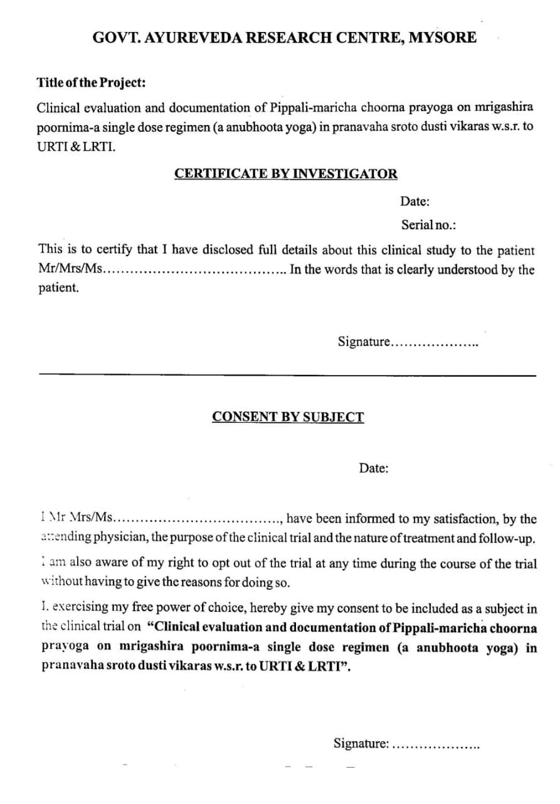

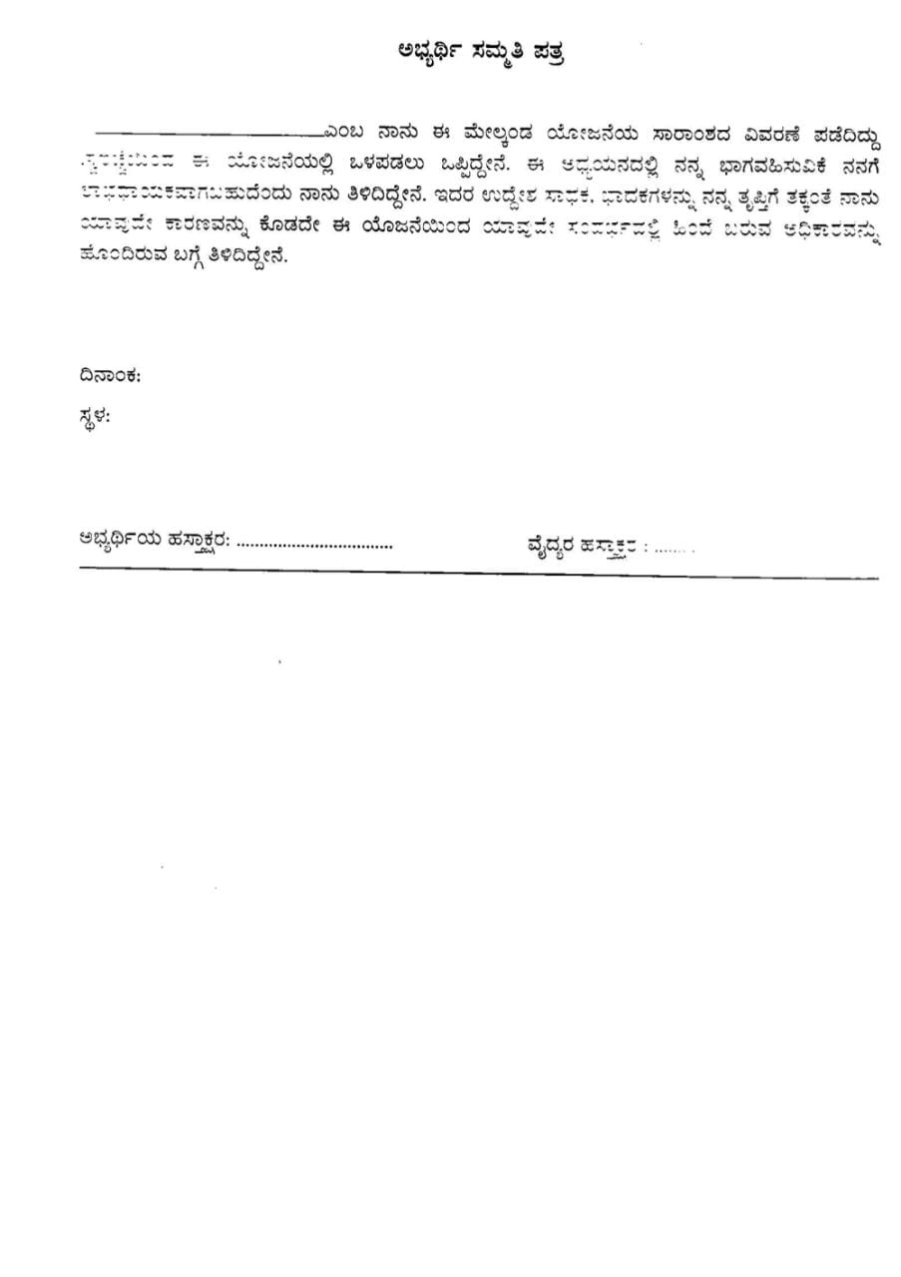

ANNEXURE 2 - CASE SHEET

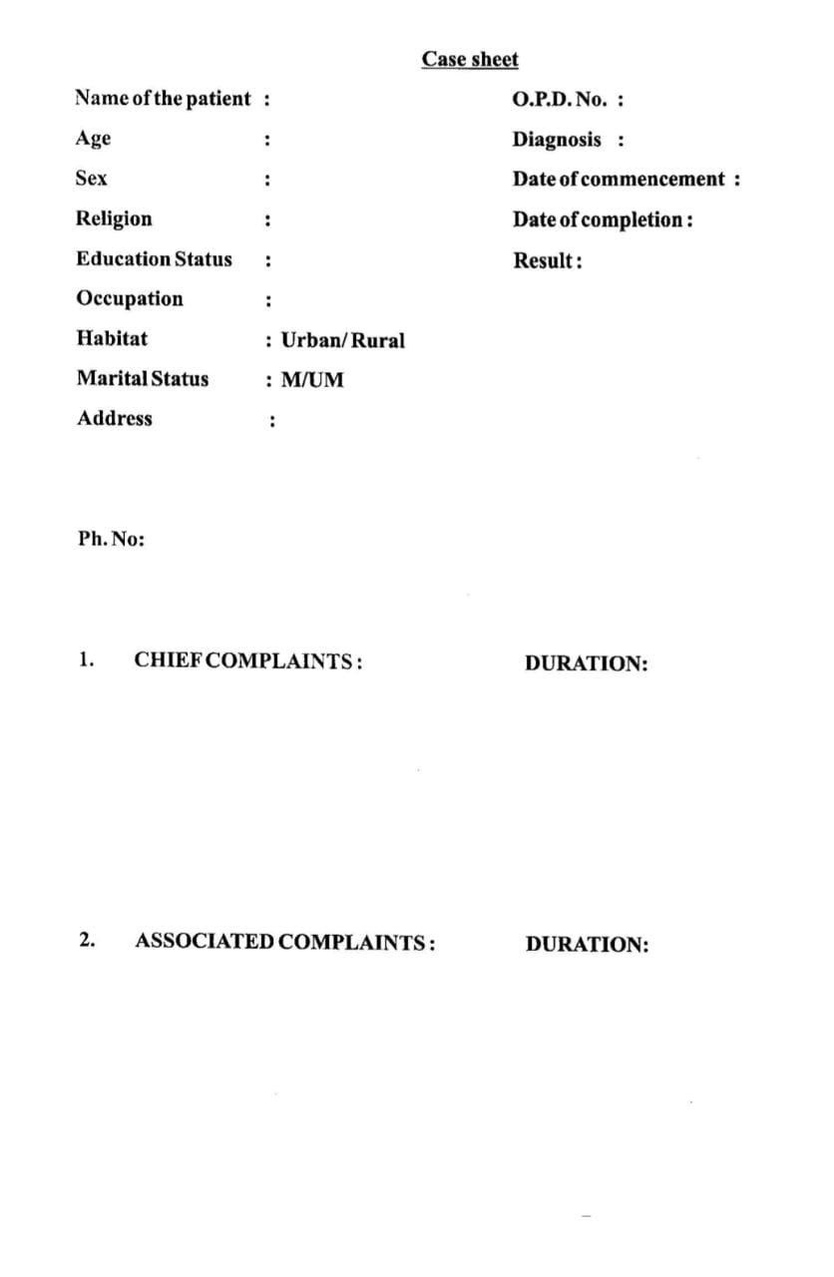

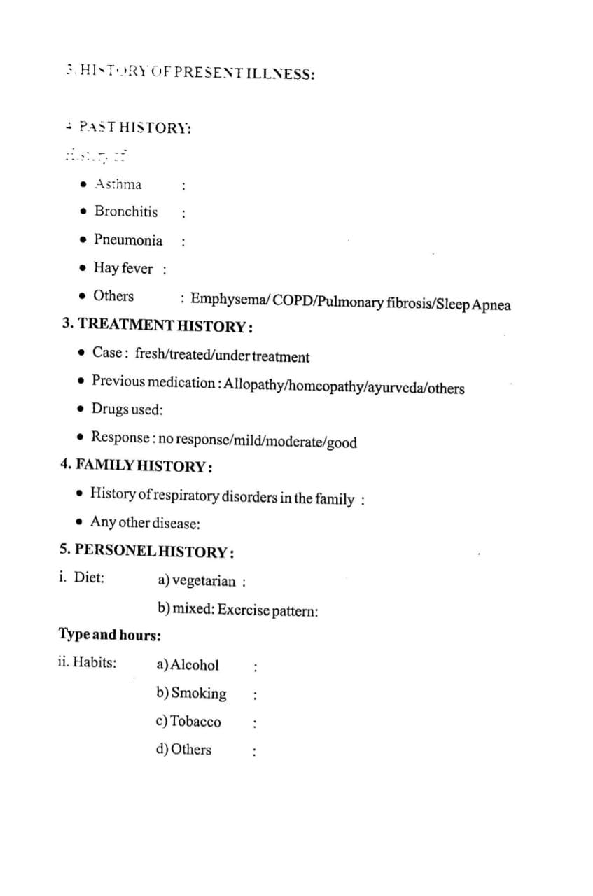

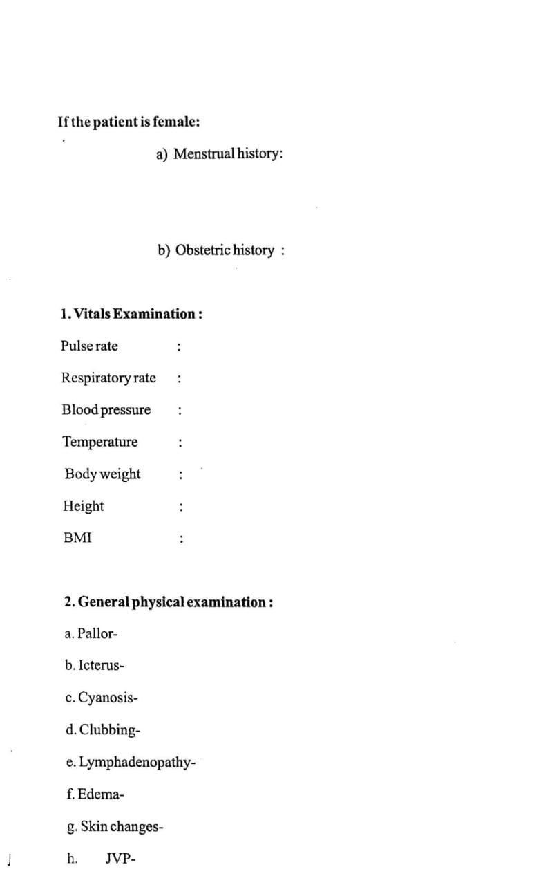

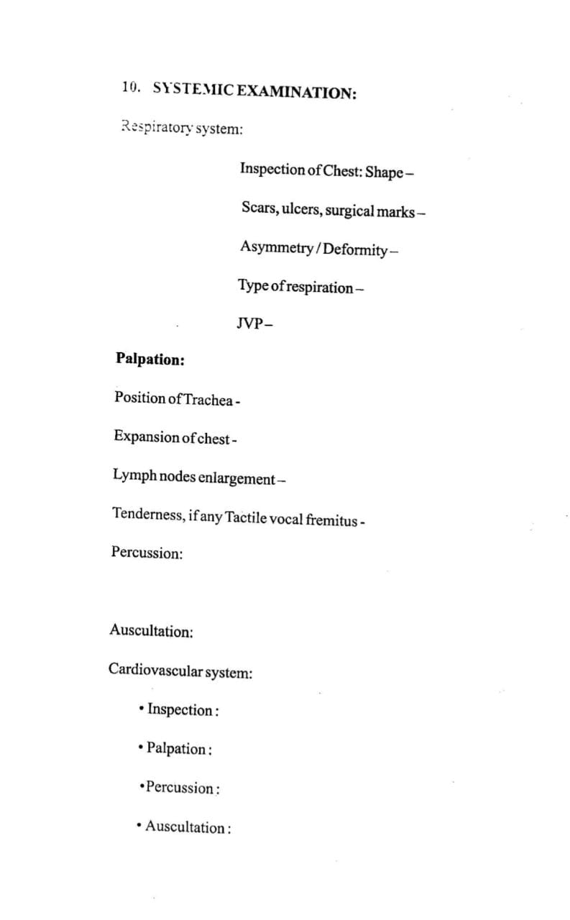

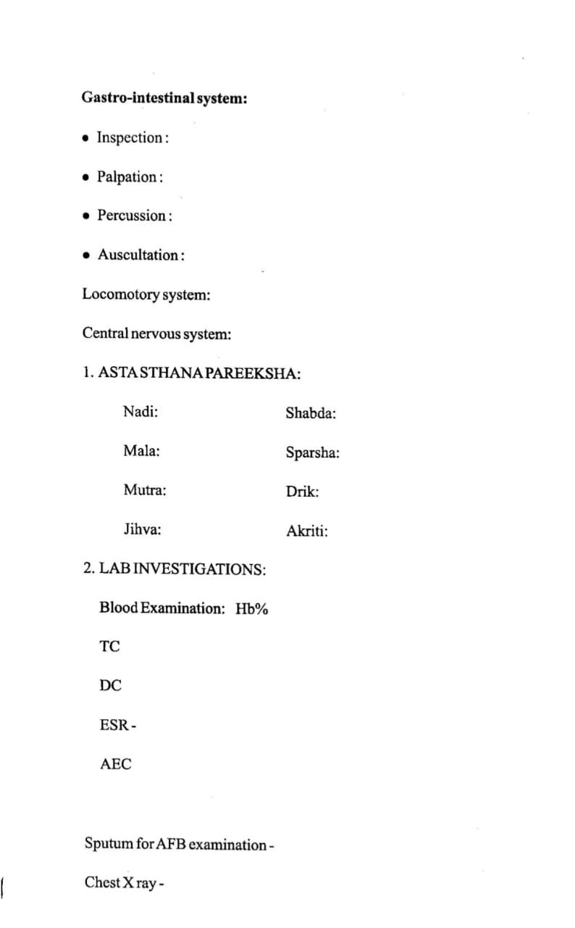

ANNEXURE 3 - INTERPRETATION

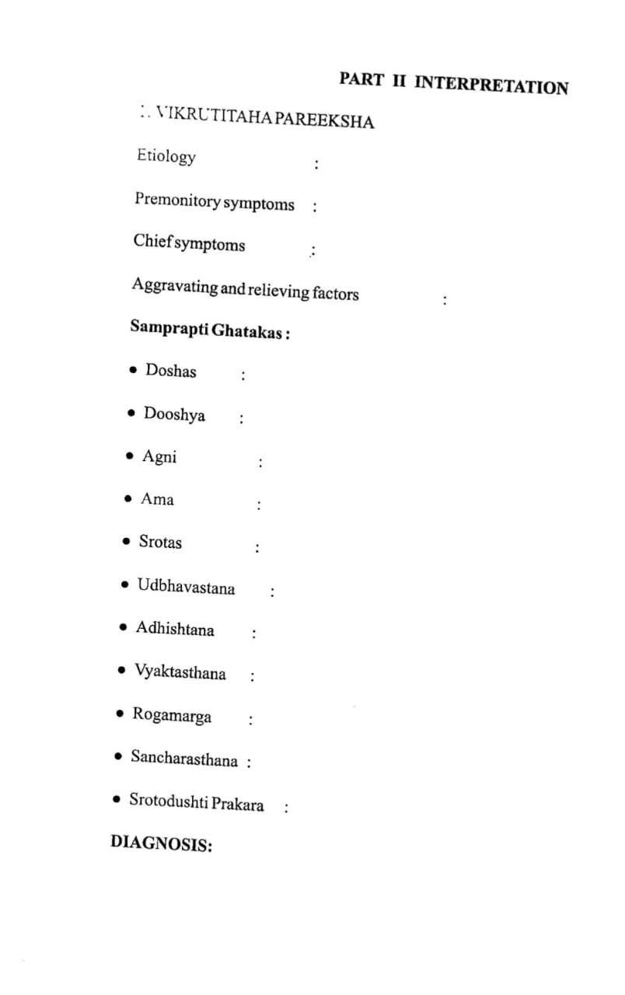

ANNEXURE 4 - INTERVENTION

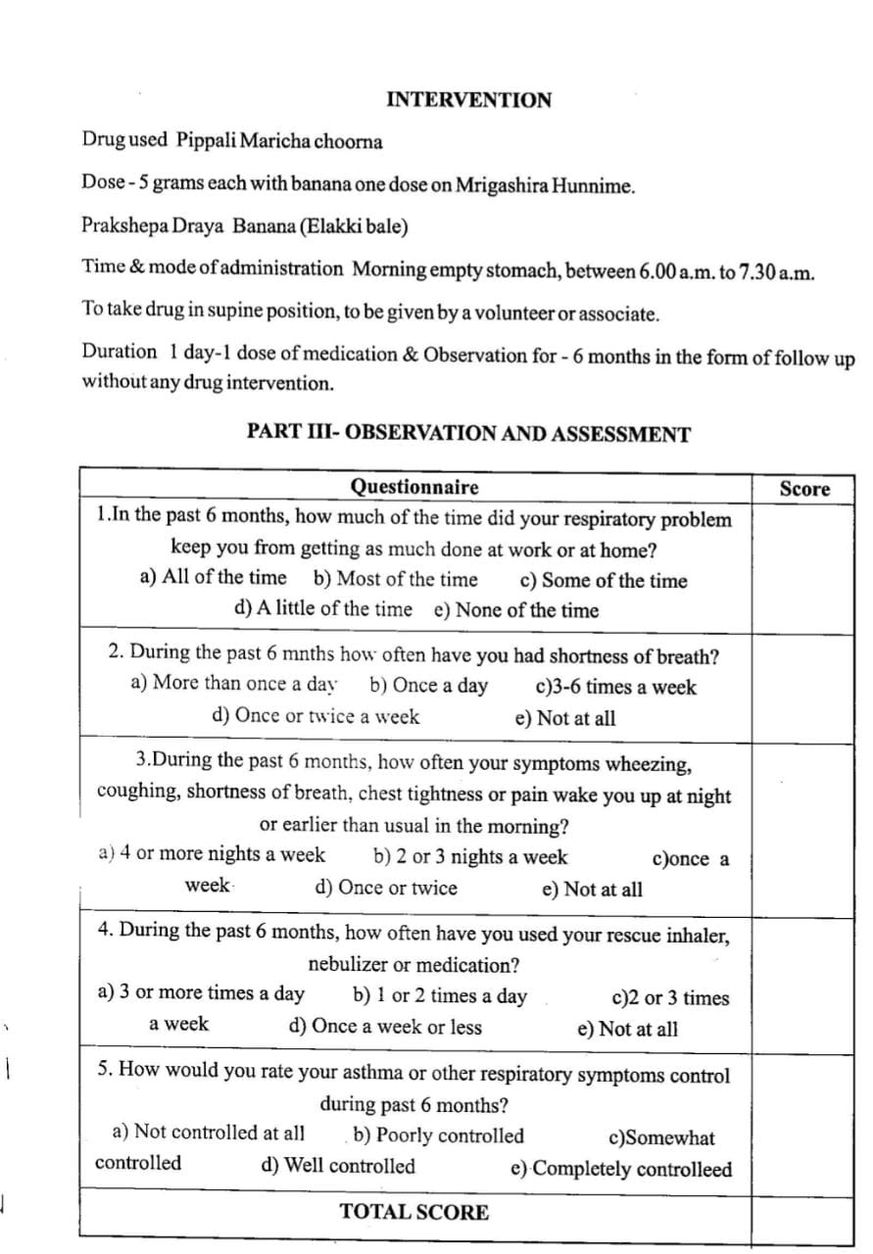

ANNEXURE 5 – ASSESSMENT CRITERIA

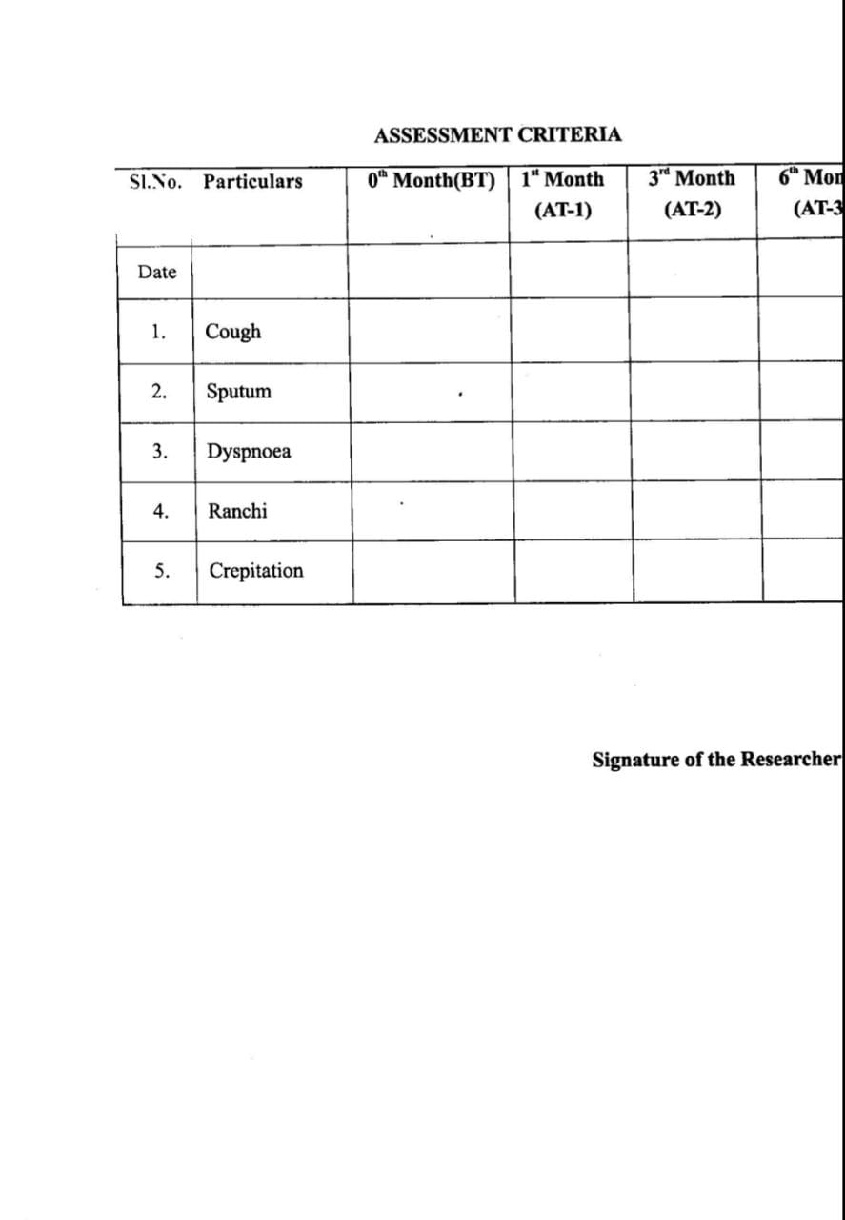

ANNEXURE 6 – SECONDARY DATA

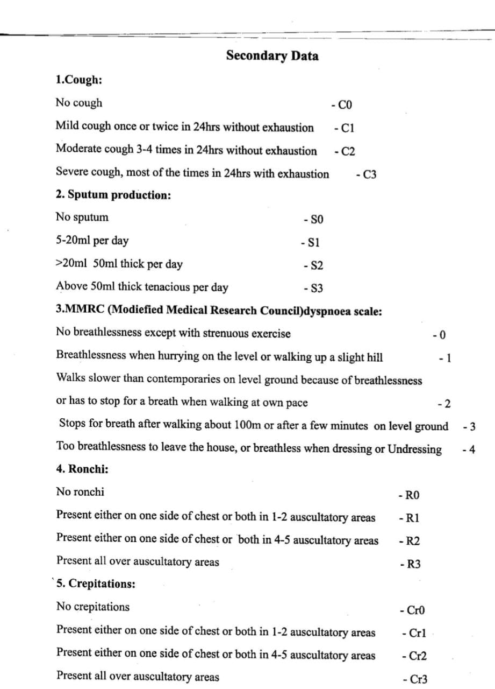

ANNEXURE 7 – QUESTIONARRIE

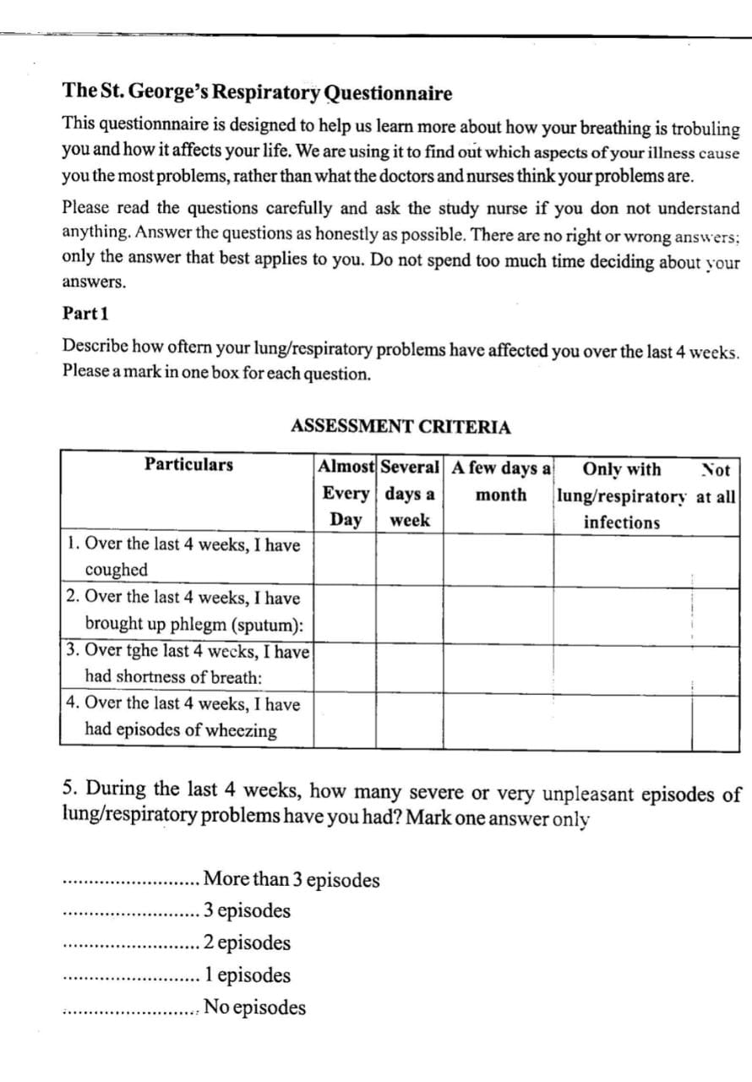

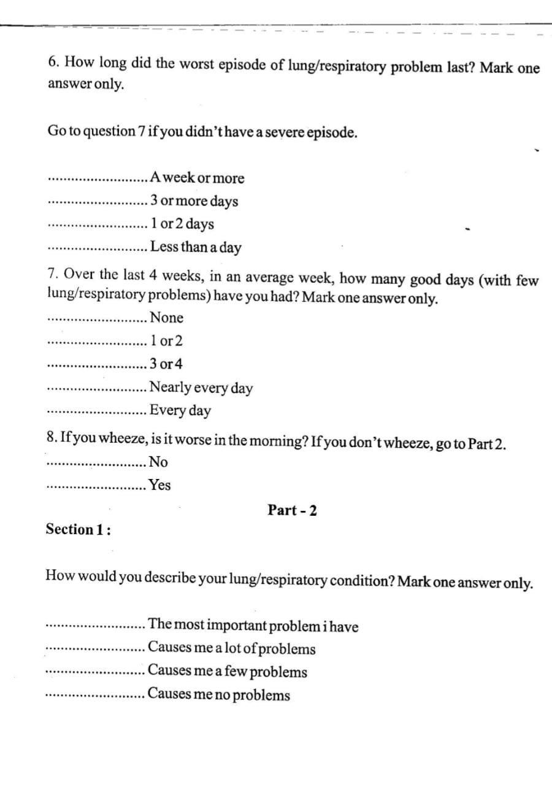

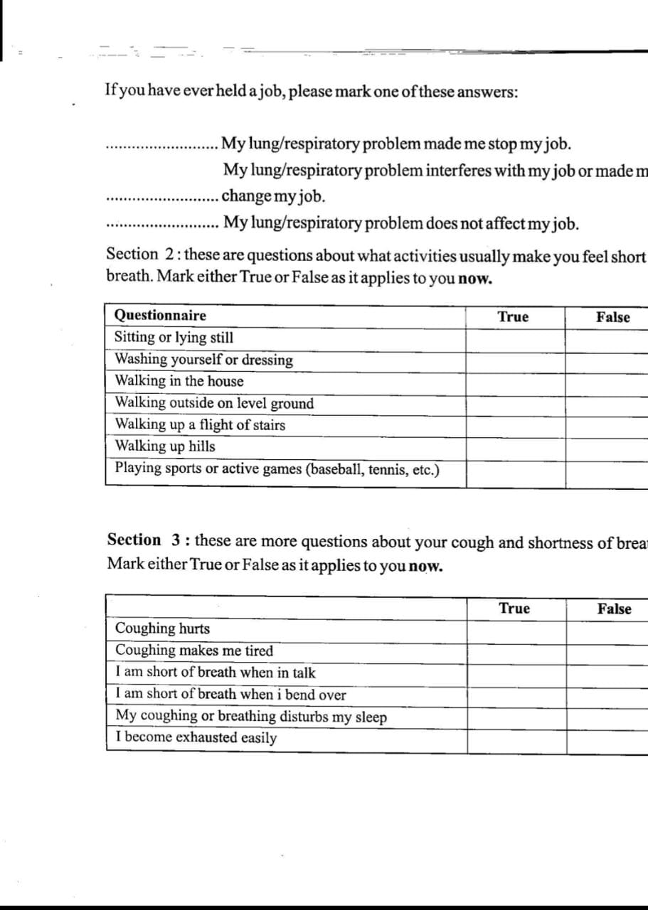

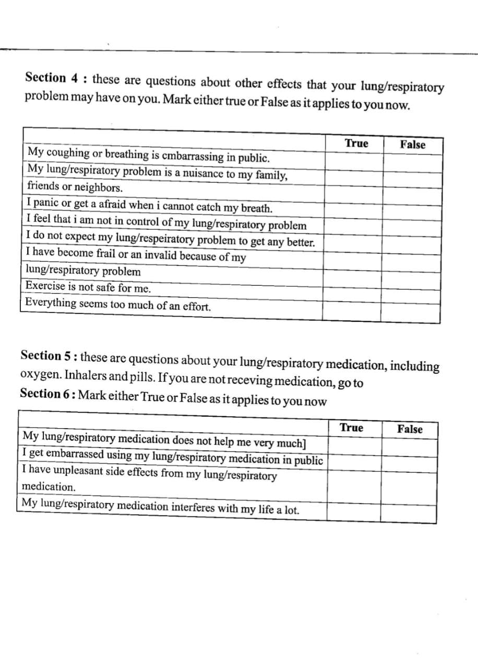

**PHTOTO GALLERY**

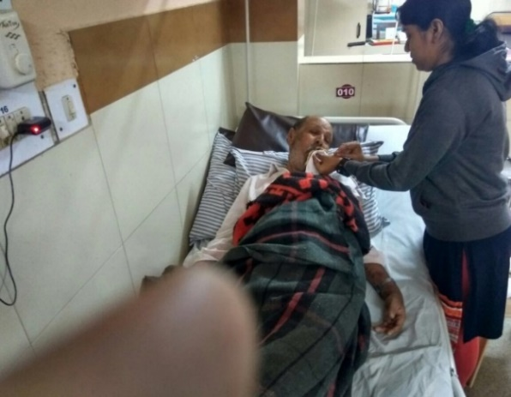

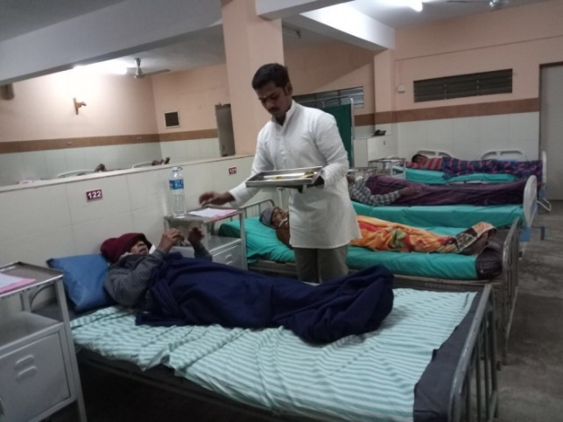

**Administration of Medicine at IPD**

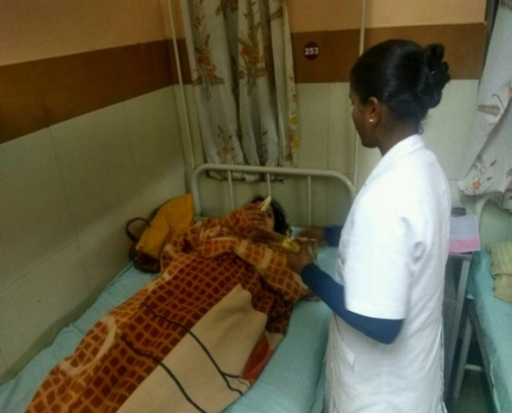

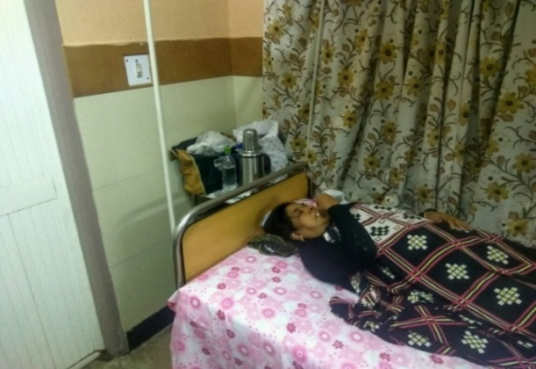

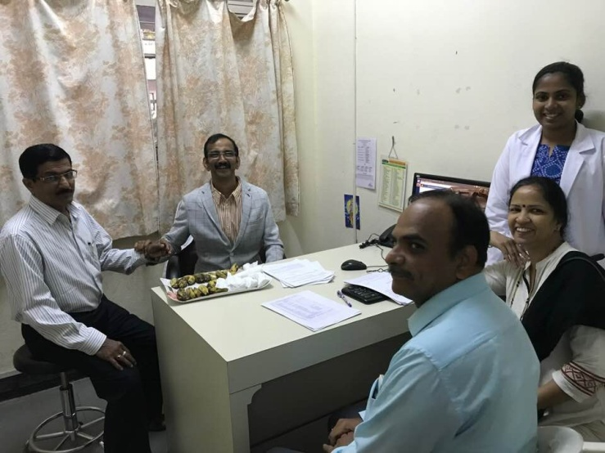

OPD CONSULTATIONS

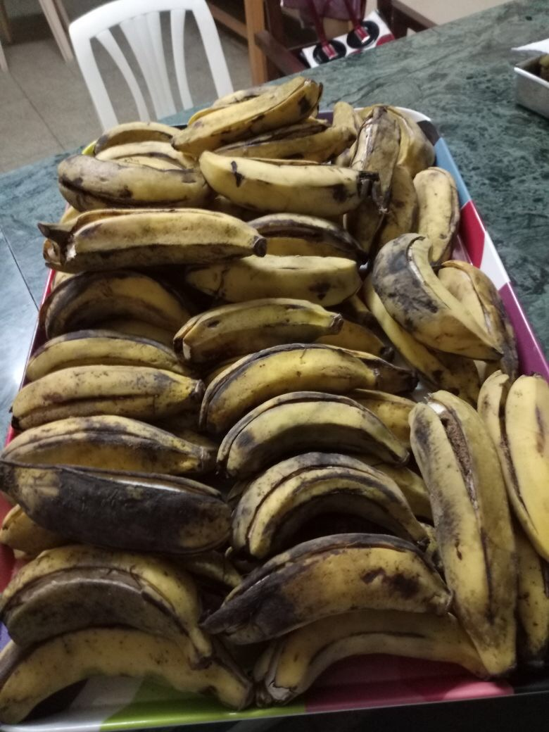

MEDICINE PREPARATION

**ADVERTISEMENT**

